Medway Learning & Teaching Conference 2024
Wednesday 26th June 2024
Pilkington Building, Medway Campus

  - Coming together to discuss courageous and compassionate approaches that will encourage students’ trust in higher education

Medway Learning & Teaching Conference is a collaborative conference from Canterbury Christ Church University, University of Greenwich, University of Kent, who all share the Medway Campus.
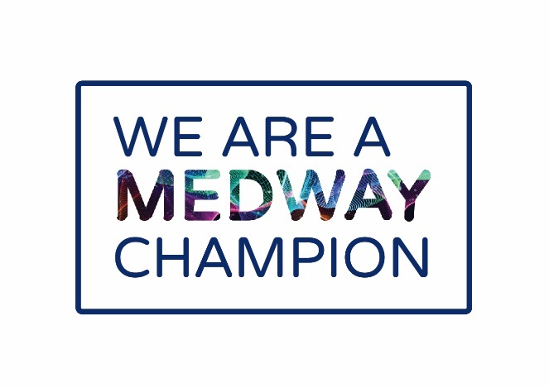
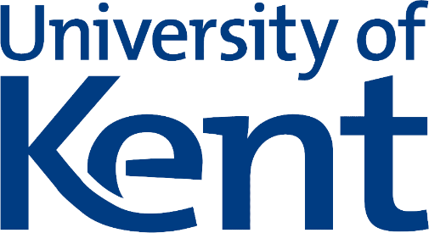
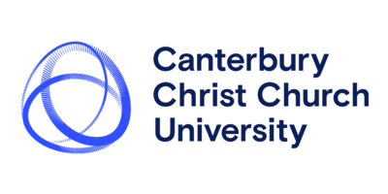
Contents
When you arrive 9
Committee’s Introduction 10
Keynote Speaker: Dr Martin Compton 12
Abstract 12
About Martin 13
Abstract 14
Abstract 14
Our Themes 16
Parallel Session 1 Session Abstracts 19
Parallel Session 2 Session Abstracts 26
Parallel Session 3 Session Abstracts 32
Layout of our Conference 40
Accessing the Conference in-person 44
Accessing via Car 44
Accessing via Train 44
Accessing via Bus 44
Accessibility and amenities 45
Parking 45
Getting Around 46
Toilets 46
Food and Drinks 46
Getting help 46
Our Conference Committee 48
Special Thanks 48

PUT

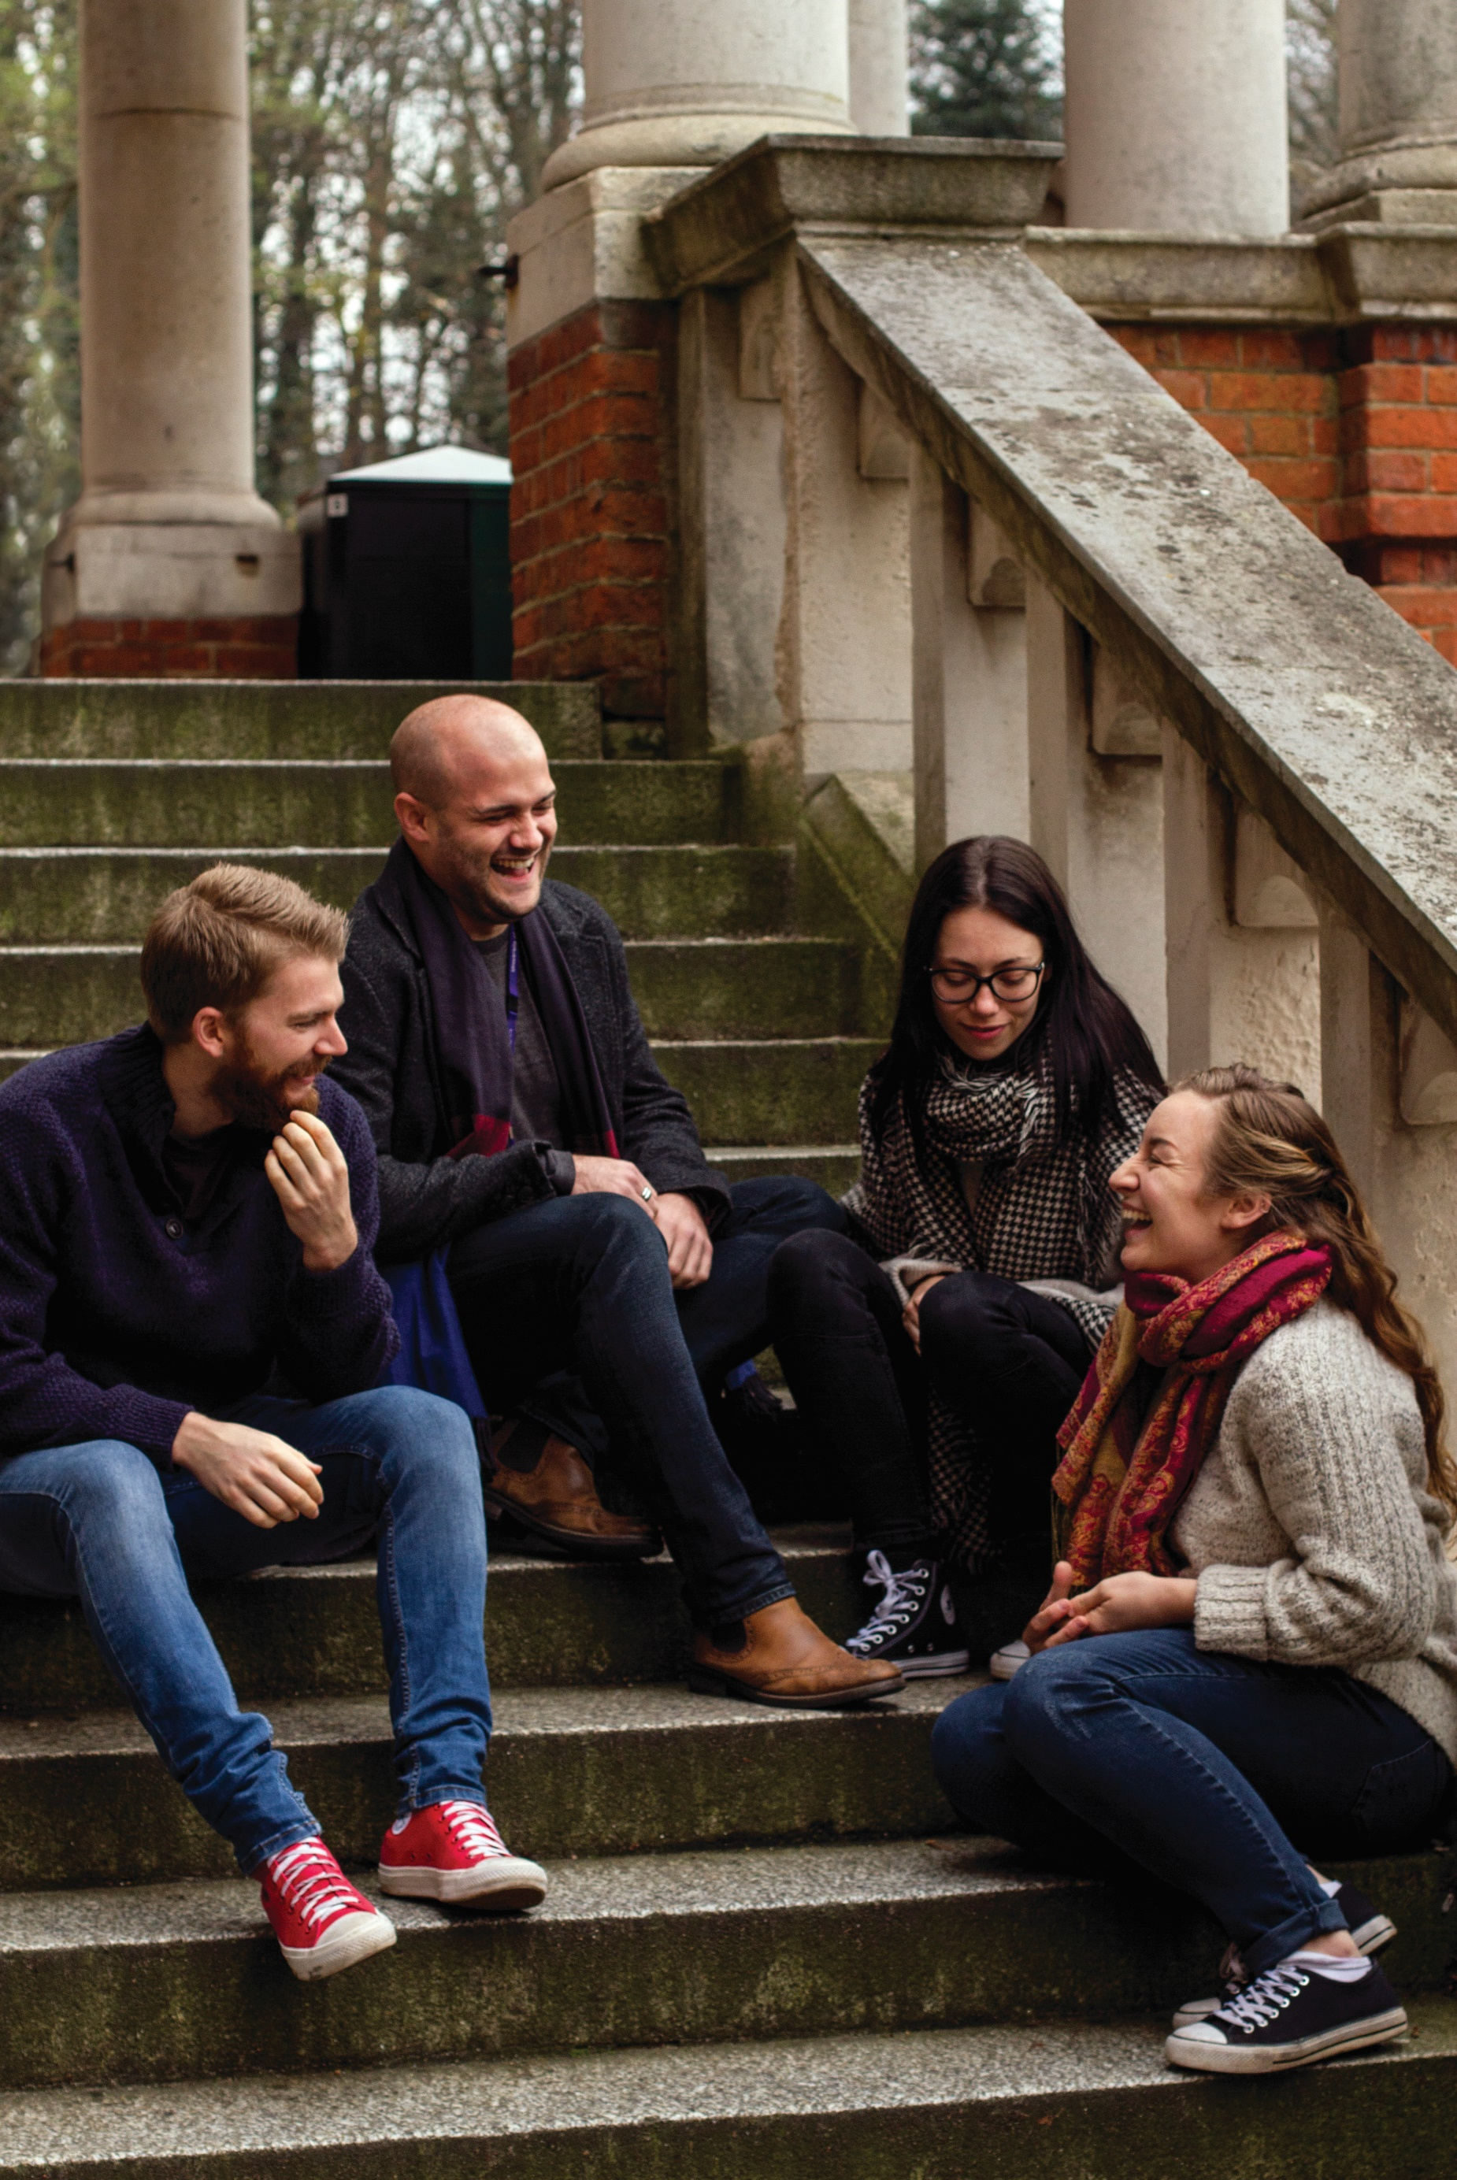
 | Lecture Theatre: PK008  (Facilitators: Chloe & Lynne) | Room 1: PK014  (Facilitators: Claire) | Room 2: PK107 (Facilitators: Dan) | Room 3: PK130  (Facilitators: Emma & Julie)
9.30-9.40 | Opening address  Dr Ali Eyden, Dean of Learning & Teaching, Canterbury Christ Church University
9.45-10.45 | Quiet Space | Critical thinking BREAD and butter - a thinking tool fit for the age of AI - David Bedford  Adapting to AI and the Future of Work: Rethinking University Education and Preparing Students for the AI-driven Workplace – Hiu Fung Jimmy Lo  Educationally Authentic Assessment: What Students Valued about their Most Interesting Assessment during HE - Kathleen Quinlan, Guadalupe Sellei, Wissia Fiorucci ( | Building Learning Community through Multi-Cohort Practical Sessions: A Case Study from Sport Coaching - Katie Dray  Preparing disabled students for university: STAART sustained support -Melanie Thorley, Serena Christie | Panel Discussion: Peer Mentoring: Unveiling Higher Education's Hidden Jewel – Celso Lopez  Panel Discussion: Fostering engagement through student-led approaches to facilitate lifelong learning: the case study of BioMed Online Learning - Giulia Getti, Karim Mahmoud  Please note this session will finish at 10.55 to accommodate the two panels.
10.45-11.00 Break – refreshments: Pilkington foyer
11.00-12.00 | Quiet space | Fostering Learning beyond university: A Case study of a STEM academic's Journey on YouTube and LinkedIn - Michael Okereke  Action Research: ‘Co-Working and Writing’ Supporting and creating writing spaces for Undergraduate Health students - Nicole Holt  An insight at peer assessment of group work in civil engineering - Ahmed Elamin, Panos Kloukinas | Students’ perspectives on participating in shared modules: Benefits and Challenges - Sallyanne Decker, Stuart Sims, Rachel George, Maria Mateo Recao, Lianfeng Quan, Robert Willson  Co-constructing knowledge between educators and their students - a pedagogical approach to teaching and learning in the HE. - Ade Magaji, Michael Adjani  Pedagogical approaches to inclusive education and decolonising the curriculum as both sides of the spectrum: what does it entail for us as educators? - Ade Magaji, Samuel Coombes, Lorraine Smith | AI as a Constant Companion - Stuart Smith
12.00-12.45: Lunch. Pilkington Refectory
12.45-13.30 | Senior Leaders’ Plenary. Discussion of the conference theme Courage, Compassion & Trust: Helping students see the value of Higher Education and what it means for each institution, followed by Q&A  Professor Niamh Downing, Pro Vice Chancellor Education & Student Experience, Canterbury Christ Church University, Professor Peter Griffiths, Pro Vice Chancellor & Executive Dean Engineering & Science, University of Greenwich and Professor Gurprit Lall, Strategic Lead for Medway and Deputy Director of Division (Natural Sciences).
13.35 – 14.35 | Quiet space | Designing a 'Climate Escape Room' to teach university staff and students about climate science - Laura Hackett  TikTok as Educational Tool for Health Students - Nicole Holt  Student and staff perceptions of generative AI: its uses, abuses and futures in higher education - Emma Kennedy, Hiu Fung Jimmy Lo, Naima Purnima, Sumaiya Taher | Perceptions of Students’ Mathematical Development in Undergraduate STEM Subjects from the Perspectives of Students and Lecturers - Richard Harrison, Anna Vines, Rianna Lin  Law Students as Change Agents and Co-Producers of Knowledge in Decolonising the (Legal) Curriculum - Renginee Pillay, Darine Haidar, Susheelwant Singh, Patricia Dubin | Assessment Feedback: student and staff views on written and audio feedback - Gemma van Vuuren Cassar;  Feedback, the ‘how’ and ‘when’ of a successful feedback strategy - Giulia Getti  Widening engagement and access in STEAM subjects – Lessons from the Voluntary Sector - Angela Stokes
2.35-2.45: Break
14.45-15.15 | Students’ plenary  Students from Canterbury Christ Church, Greenwich and Kent participate in a discussion about the conference theme Courage, Compassion & Trust: Helping students see the value of Higher Education and what they see as the future of HE
15.20-16.15 | Keynote address  Dr Martin Compton, College Lead for AI and Innovation in Education and Programme, Module & Assessment Design Lead at King’s College London. Theme: AI3: Crossing the beams of artificial intelligence, academic integrity and assessment innovation. Martin considers three increasingly intertwined AIs: artificial intelligence; academic integrity; and what now seems urgent: assessment innovation.
16.15-16.30 | Conference closes

When you arrive
- Registration: Proceed to the Registration desk to check in. This will be located in the corridor as you come into the North Entrance of Pilkington Building.
- Lunch: Collect your complementary Lunch voucher from the registration desk (1 per person for a single transaction up to £6 at the Pilkington Café).
- Refreshment: Help yourself to free refreshments in the corridor next to the lecture theatre (PK008) or feel free to purchase other refreshments from the Pilkington Café in the foyer.
- Keep updated: Check the posters located around the building of the up-to-date schedule of all the sessions happening in the day.
- Questions: If you have any questions or need any help, please do not hesitate to speak to one of conference organisers who will be wearing a badge with a blue dot sticker on it.
- Orientate: Use the map in the programme to help you locate the different areas where sessions will be held. There will be signs and conference organisers to help guide you on the day.

Committee’s Introduction
Welcome and thank you for joining us for the Universities at Medway Learning and Teaching Conference 2024. The conference is jointly organised by the Universities of Canterbury Christ Church, Greenwich and Kent. The three institutions take turns to lead on organisation and this year it is Canterbury Christ Church’s turn.
The theme this year explores Courage, Compassion & Trust: Helping students see the value of Higher Education. These are challenging times for Higher Education. This conference offers a platform for our speakers to show how HE provision is still valid, current and an excellent way to build skills and knowledge for a productive and successful future. Our speakers will also offer ideas and inspirations for shaping minds, shaping communities, and critical thinking for compassion and empathy.
We have an exciting range of sessions in our programme this year that range from presentations, lightning talks, case studies, panel discussions and workshops. We will also be hosting a Senior Leaders Plenary and a Students’ Plenary which will give you the opportunity to see how the conference theme is interpreted and illustrated from different perspectives.
We are delighted that Dr Martin Compton is our Keynote speaker this year and he will be closing the conference with his talk on the three types of AI we should be aware of - AI3: Crossing the beams of artificial intelligence, academic integrity and assessment innovation. With the interest around the use (or misuse) of artificial intelligence in HE Martin explores a reflective approach and advocates radically rethinking assessment.
As we mentioned, this conference has been a joint venture involving all three universities at Medway. We would like to thank all those presenting on the day and to the members of the organising committee for devoting their time, ideas, and enthusiasm to help make this happen.
Finally, very many thanks Angeliki Voskou, Peter Brown, Tom Gale, Annikki Laitinen and Kathleen Quinlan for their support, suggestions and help in all aspects of the conference organisation.
We hope you enjoy the day!
Chloe Courtenay, Julie Taylor and Jack Charter

Keynote Speaker: Dr Martin Compton
AI3: Crossing the beams of artificial intelligence, academic integrity and assessment innovation
Lecture Theatre PK008, 15:20 – 16:15

Abstract
Artificial intelligence appears to permeate every conversation in HE and it's easy to forget that it is a phenomenon not designed solely to make the lives of those of us working in HE harder. Reflecting increasing polarisation in the wider World, its present and future effects have been divisive. With so much uncertainty and so many competing narratives and immediate and pressing anxieties, how might we tackle the implications of these incredibly disruptive and rapidly evolving technologies?
In this keynote, Martin considers three increasingly intertwined AIs: artificial intelligence; academic integrity; and what now seems urgent: assessment innovation. Amidst a cacophony of predictions ranging from the utopian to the dystopian, Martin argues for a reflective approach to our assessment practices. Is the detection of AI usage the most effective strategy, or is it time to radically rethink our approaches to assessment itself? This presentation will not only navigate the uncharted territories of technological impact but will also challenge us to reconsider the very purpose of assessment in education. Join Martin as he risks crossing the three AI beams and offers reflections, provocations and insights into how we might imagine and then realise a different assessment future.

About Martin

Dr Martin Compton is College Lead for AI and Innovation in Education and Programme, Module & Assessment Design Lead at King’s College London.
He has been an educator for over 30 years, affording him ample time to realise that it takes a lifetime of teaching to get the hang of it. In that time, he has had the privilege of teaching children, young people and adults. His teaching has spanned secondary schools, international schools, further education colleges and universities both in the UK and overseas. Having spent a number of years at the University of Greenwich and then UCL, in July 2023 he took up a post at King's College London where he was employed to lead on curriculum and assessment design but as it turned out he has spent most of his time looking at ways in which the opportunities and threats of AI will necessitate changes to pedagogy, assessment and feedback practices across higher education. His role as College Lead for AI in Education gives him the opportunity to help colleagues reflect on, critique and reimagine teaching and assessment design and other ways of elevating a 'freedom to learn' philosophy.
Plenary sessions
This year we have two plenary sessions. Both are discussing the conference theme ‘Courage, Compassion & Trust: Helping students see the value of Higher Education’.
The Senior Leader Presenters
Professor Niamh Downing – Pro Vice Chancellor for Student Experience and Education, Canterbury Christ Church University
Professor Peter Griffiths – Pro Vice Chancellor, Engineering and Science, University of Greenwich
Dr William Collier – Director of Education, University of Kent

Abstract
This session will bring together senior colleagues from Canterbury Christ Church, Greenwich and Kent who have a strategic role which plays a part in shaping learning and teaching and supporting academic development. In the first part each senior leader will outline how the theme is relevant to his/her institution, and this will be followed by a Q&A. This session should help identify the institutional approach to courageous and compassionate approaches as well as highlighting what is being done to encourage students’ trust and how this will build a brighter future.
Lecture Theatre, PKoo8. 12.45-13.30.
The Student Plenary Presenters
Alma Shkreli (Greenwich)
Halle Mills (Canterbury Christ Church)
Hanan William (Canterbury Christ Church)
Ole Ozoemena (Kent)
Olivia Adekunle (Kent)
Susanne Martin (Greenwich)

Abstract
This session will bring together students from Canterbury Christ Church, Greenwich and Kent to illustrate how they imagine the future of Higher Education as well as their perspectives on the conference theme. It is important to hear students’ viewpoints of their experience of Higher Education and how it should evolve.
Lecture Theatre, PKoo8. 14.45-15:15.
This s
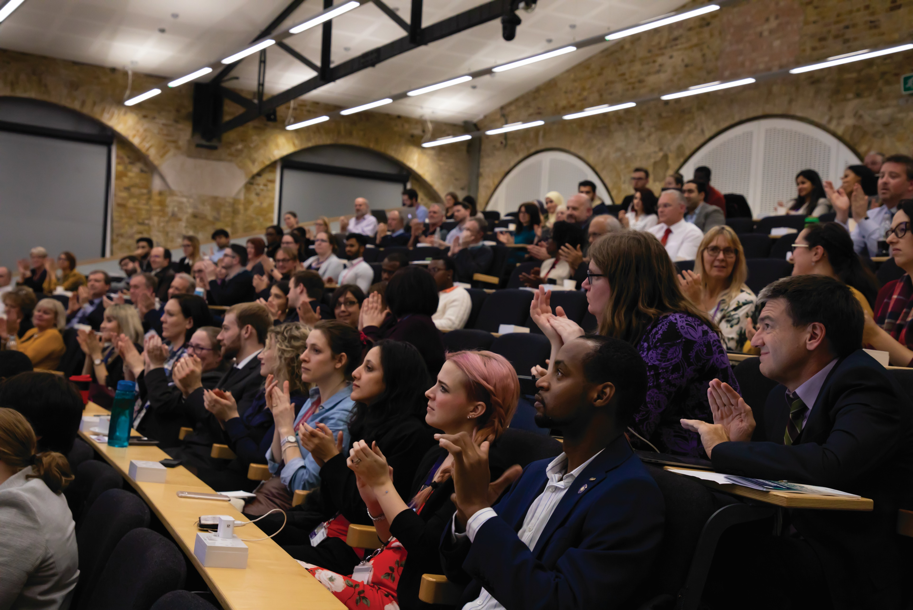

Our Themes
Conference theme: Courage, Compassion & Trust: Helping students see the value of Higher Education
These are challenging times and Higher Education (HE) is feeling the pressure. We need to show that HE provision is still valid, current and an excellent way to build skills and knowledge for a productive and successful future. Two genuinely unique contributions that HE brings to education are, one, a 'way of thinking' , which broadly defined - it trains you to think and be a certain way in the world (variously packaged as critical thinking/ reflexive thinking/ independent learning/ lifelong learning, depending on context and emphasis). Two, it offers access to expertise from a range of disciplines and promotes an understanding of the interconnectedness and relativity of knowledge, which in itself promotes compassion. Our theme calls for ideas and inspirations for shaping minds, shaping communities, and critical thinking for compassion and empathy.
Sub-themes
- Building communities of learning beyond the university. This might be your experience of expanding outreach to local colleges and sixth forms. Ways in which you can inspire young people to study beyond school. How to do this differently/more effectively, considering the underfunding of FE colleges nationally, but particularly locally.
- Finding new and courageous approaches to areas such as academic integrity. Advocate for an educative rather than a punitive approach and showcase what good academic practice is and why we should aspire to it. Avoid visiting epistemic injustice on our staff and students.
- Avoiding moral panic around Generative AI. AI has the power to aid higher education and employers are increasingly going to expect graduates to be comfortable and trained to use AI efficiently and ethically. Take the focus away from fears of students cheating and more on how it can be used for educational development.
- Challenging the 'bare minimum' narrative. Inspiring students through challenging curriculum to think beyond their subject boundaries - teaching using growth mindset techniques.
- Active use of learning development to promote compassion within the University. E.g., challenging 'they should already know that' attitudes to (particularly) assessment literacy e.g., being able to write an essay. This is where generative AI could be used in a helpful way, as many second-career academics don't have these writing/ research skills themselves, or the time/support to develop them.
- Actively building knowledge networks with cohorts. Teaching with methodologies that promote social cohesion, and providing the space and timetabled hours to do so. Building a strong argument for reducing 'independent learning time' in modules, which students read as 'time to go and do the housework/pick up the kids/earn' and facilitating them being on campus, working together, facilitated by tutors. This might be through a collaborative approach with lecturers, learning development teams, library staff, and student support forming integrated teaching teams to learn how to learn together.
- Making space in PSRB curriculums for humanities-based approaches to science education, e.g., interdisciplinarity in health-care, education, nursing, humanities, social sciences, etc.
- Advocate for how critical thinking skills promote empathy and compassion e.g., through the normalisation of multiple perspectives (this is usually achieved through clinical supervision in nursing), but alternative approaches such as literature based approaches would be a really exciting and novel way to explore increasing reflection and empathy in clinical trainees).
- Bringing communities on board with Higher Education. with students increasingly choosing not to go to university at 18 this is an interesting opportunity to explore what we can do to encourage them to have more trust in higher education and what new and courageous approaches we can take.

Parallel Session 1 Session Abstracts
Critical thinking BREAD and butter - a thinking tool fit for the age of AI
PK014, 9:45 - 10:05
David Bedford
Canterbury Christ Church University

Presentation

This paper presents BREAD, a thinking tool for basic evaluation and selection of information sources, and discusses how it can be used with students, particularly with the challenges that AI-generated information is thought to bring.

BREAD was developed at the Medway campus by librarian David Bedford, as a tool to help health students overcome the anxieties they express over the amount of information available and the difficulties they have in selecting appropriate and "academic" information from it. Rather than giving students a checklist, it encourages them to consider information sources from 5 perspectives – bias, relevance, evidence, author and date – and use these to guide their reading choices and the extent to which they wish to rely on the information they find. Although created specifically for the needs of students from health courses, it has been used successfully with students from other disciplines as well.

BREAD is primarily accessed via in-class teaching, but a post about the tool has appeared on the Nursing Times readers’ blog (Bedford, 2018) and it will feature as a chapter in a forthcoming book.

The paper has three sections. First, an explanation of the rationale for BREAD and its 5 elements. Second, an interactive demonstration of parts of how this is taught. And third, a consideration of the implications of AI for source evaluation and the BREAD approach to it.

Although generative AI changes the nature of some elements of BREAD, particularly authorship, the paper will discuss how the approach can help to frame classroom discussions of genAI and assist students to make critical choices about their use of information that has been generated in this way.

Reference:
Bedford, D. (2018) ‘Nurses must consider which information to use and trust’. Nursing Times readers’ blog, 13 September. Available at: https://www.nursingtimes.net/opinion/nurses-must-consider-which-information-to-use-and-trust-13-09-2018/ (Accessed: 24 May 2024).

Building Learning Community through Multi-Cohort Practical Sessions: A Case Study from Sport Coaching
PK107, 9.45 – 10.10
Katie Dray
Canterbury Christ Church University

Case Study

Fostering a sense of belonging for students in HE is increasingly recognised as an important element in the student experience, contributing to greater persistence in academic development and greater retention (Thomas et al., 2018). Moreover, the feeling of connectedness for students with their learning institution is positively associated with student wellbeing (Nash et al., 2020). The case study presented here reflects on an attempt to build and enhance the sense of belonging and community within the BSc Sport Coaching Course, by running a multi-cohort practical session as part of the curriculum for level 4, 5 and 6 students. The case study will reflect on the strategic rationale for including all course students in a jointly taught weekly coaching experience and discuss the practicalities of delivering multiple module learning objectives within the model. We will discuss the importance of encouraging student leadership, including building confidence; the staff role as a facilitator during learning; negotiating a compassionate feedback process; and our attempts to promote inclusivity within this learning environment. Reflections on this first iteration of this multi-cohort experience will include the reflections of staff teaching each of the modules taught within the practical experience and the student voice will be represented to provide reflections on their experience of the model. Key learnings from this academic year will be discussed, including the perceived benefits for students and staff and the challenges will be discussed with a view to further developing the model for 2024-25.

Panel Discussion: Peer Mentoring: Unveiling Higher Education's Hidden Jewel
PK130, 9:45 - 10:20
Celso Lopez
University of Greenwich

Panel discussion

In response to the Medway Conference's theme of "Courage, Compassion & Trust: Helping students see the value of Higher Education," our proposal focuses on the important role of peer mentoring in encouraging compassionate learning communities and building trust with prospective students. Our Student Peer Mentoring Scheme gives support and guidance for both new and current students. By pairing incoming students with experienced mentors, we facilitate a seamless transition into university life, empowering mentees to navigate challenges and embrace opportunities with confidence. Our showcase will highlight the transformative impact of peer mentoring on student engagement, retention, and overall well-being. Through a presentation involving members of the student community, we will show how peer mentors embody compassionate practices within inclusive environments where every student feels valued and supported. We will cover the approach adopted within our scheme, that permeates in different aspects of student life, including the importance of nurturing academic integrity through mentorship rather than punitive measures. Having a culture of mutual respect, we aim to cultivate ethical environments where values of honesty and integrity are the norm. The University of Greenwich's Peer Mentoring Scheme is an innovative form of promoting compassionate learning communities and promoting trust in higher education.

Adapting to AI and the Future of Work: Rethinking University Education and Preparing Students for the AI-driven Workplace Workshop Room (PK017), 10:05 - 10:25
Hiu Fung Jimmy Lo
University of Greenwich

Presentation

In the era of generative artificial intelligence (AI), universities face an unprecedented challenge in preparing students for a rapidly
changing workforce (McKinsey, 2023). Many existing skills could become obsolete, while new capabilities must emerge rapidly to avoid
technological unemployment (Keynes, 1933). Hence, universities play a critical role in equipping students with the relevant skills to adapt
and thrive in the AI-driven workplace of the future (Office for Artificial Intelligence, 2023). The presentation examines the skills university
graduates will need and discusses the crucial domains of curriculum design. The first domain is to foster an understanding of generative
AI as a collaborative partner and integrate it into universities’ teaching, learning, and assessment. Given generative AI's potential to
augment human capabilities across sectors (Nah et al., 2023), universities should adopt AI ethics and pedagogy in their curricula
(Borenstein and Howard, 2021), and protect human values as generative AI surpasses human capabilities in multiple domains (Bostrom,
2014). The second crucial domain of curriculum design is cultivating distinctively human skills. Despite advancements in generative AI,
some attributes and capabilities remain uniquely human and will be indispensable in the future (Aoun, 2017; Chomsky et al., 2023;
Santoro and Monin, 2023). Skills such as creativity and social intelligence are less susceptible to technological disruption (Frey and
Osborne, 2017). Therefore, universities should prioritise the development of these human skills across disciplines and embed them into
their curricula (Southworth et al., 2023). This presentation explores some key issues guiding educators as they rethink how to prepare
students for the future of work. It examines the scale and timeline of AI's impact, assessing when and where it will disrupt traditional
roles and industries. The presentation also discusses how universities can adapt to this transformation and equip students with the
necessary skills and knowledge to thrive in an AI-driven economy.

Preparing disabled students for university: STAART sustained support
PK107, 10:10 - 10:35
Melanie Thorley, Serena Christie
University of Greenwich

Case study

STAART is aware the main reason university students do not succeed in higher education is lack of preparation and/or a mismatch between the university expectations and the expectations of students. We will disseminate how our *STAART Sustained Support (*SSS) has been preparing a number of Hadlow students for university. We will discuss the challenges faces by SEND/disabled students, and some of the difficulties of providing sustained support within a further education setting. The feedback from the students and staff has been outstanding and the presentation will include testimonials from students and staff.

Panel Discussion: Fostering engagement through student-led approaches to facilitate lifelong learning: the case study of BioMed Online Learning
Workshop Room (PK130), 10:20 - 10:55
Giulia Getti, Karim Mahmoud
University of Greenwich

Panel discussion

Online learning is the fastest-growing market in the education industry with a 900% growth reported since 2000¹. Currently most, if not all, universities deliver programmes through online distance learning. Amongst the many advantages to online learning, such as flexibility, accessibility and cost; challenges remain. The main challenge being the low completion rate, which was reported at 12.6% in the US², with similar data in the Commonwealth, where only about 15% of Open Universities students completed a degree or other qualifications³.

The University of Greenwich's BioMed Online Learning provision has successfully overcome this challenge as shown by a consistent high retention rate of 95% achieved over the years. The BioMed Online model focuses on student-led learning approaches which encourage engagement and promote the development of a supportive learning community. The BioMed programme offers truly flexible learning for working biomedical scientists and healthcare professionals, while utilising tutors with real-world work experience. These specialists facilitate practice-based discussions led by students to contextualise the module learning outcomes – on a wide range of subjects ranging from Quality Systems Management to Haematological Malignancies. Key to the programme’s success and high degree of student satisfaction, we argue, is the engaging student-led and tutor facilitated sessions that are a defining feature of the BioMed programme. In this session, led by Giulia Getti and Karim Mahmoud, the BioMed Online co-directors, attendees will hear more about the student-led model and will receive pragmatic guidance and recommendations based on a real-world example. By providing actionable insights on the practice-based and student-led model, it is hoped that the session will encourage discussion and provide an opportunity to explore alternative models of online student engagement.

[1] Environmental Benefits of Online Learning – https://www.growthengineering.co.uk/wp-content/uploads/2021/06/Environmental-Benefits-of-Online-Learning-Infographic-Growth-Engineering.pdf

[2] Jordan, Katy (2015). Massive open online course completion rates revisited: Assessment, length and attrition. International Review of Research in Open and Distributed Learning, 16(3) pp. 341–358.

URL: http://www.irrodl.org/index.php/irrodl/article/view/2112/3340

[3] Mishra, S. (2017). Open Universities in the Commonwealth: At a Glance. Availble at: http://hdl.handle.net/11599/2786 (Accessed August 21, 2021).

Educationally Authentic Assessment: What Students Valued about their Most Interesting Assessment during HE
PK014, 10:25 - 10:45
Kathleen Quinlan, Guadalupe Sellei, Wissia Fiorucci
University of Kent

Presentation

With increasing calls for authentic assessment in higher education, we advance the notion of educational authenticity. How can educators design assessments that students will see as valuable learning experience, not just something that tests them? In a staff-student partnership project led by the Kent Union, we surveyed more than 600 students across the subjects taught at the University of Kent about their most interesting, engaging assessment. We then analysed 301 qualitative responses that explained why the selected assignment was so engaging. Students cited a wide range of different types of assignments, though variations on written assignments and practical assignments were most frequently described. Respondents’ most common reason offered for why the specific assignment was most engaging related to having choice in some aspect of the assignment. The second most common reason was that the assignment enabled them to make real-world connections. We will give examples of different ways that students appreciated choice and real-world connections, suggesting relatively straightforward adjustments to assignments that might increase their value from the perspective of students. We will briefly discuss the findings in relation to authentic assessment literature, considering how understanding and designing for educational authenticity can lead to various, valued outcomes highlighted in
existing authentic assessment literature. We will invite session attendees to reflect on their own assignments to see how they might use the strategies highlighted in the examples to increase value to students.

Parallel Session 2 Session Abstracts

Fostering Learning beyond university: A Case study of a STEM academic's Journey on YouTube and LinkedIn
PK014, 11:00 - 11:20
Michael Okereke
University of Greenwich

Case study

The world of higher education is changing rapidly with evolution of generative AI and the pressure on finances of universities. Traditionally, universities have stood at a standstill for decades offering the same face-to-face lecture-style models. Following the Covid Pandemic, there have been some improvements on university's provisions around flexible learning and flipped classroom pedagogies. However, it is the view that these are still limited if we are to remain consistently competitive in a highly digitized and global learning environment.

One thing academics have not been good at over the years is leveraging the opportunities posed by social media to communicate ideas, educate a global audience, and build competitive advantage for the universities not only in their teaching and learning but also in their research. All these when done properly will help a diverse community of learners in a global classroom to learn adequately and respond agilely whilst also providing additional funding for the universities, provide measures of esteem and even make universities more and more competitive.

In this case study, I, a STEM academic from School of Engineering, am showcasing my three-year journey on YouTube and LinkedIn which have significantly enhanced my offering to my students in higher education, grown my international reputation, attracted book deals whilst also offering bespoke education to subscribed international students. This case study is a showcase of how I have been able to grow a highly subscribed YouTube channel and LinkedIn Newsletters which created sustained engagement in a very niche teaching and research area of computational modelling. I will showcase the steps taken, discuss the pros and cons, the pitfalls, the tears and triumphs and offer a pathway for most academics to begin to take their teaching, learning and research beyond the four walls of the classroom to a boundless global community of learners.

Students’ perspectives on participating in shared modules: Benefits and Challenges
PK107, 11:00 - 11:20
Sallyanne Decker, Stuart Sims, Rachel George, Maria Mateo Recao, Lianfeng Quan, Robert Willson
University of Greenwich

Presentation

Module sharing is a common feature in the design of academic programmes and is set to play an increasingly important role in the future of programme delivery. In shared modules, students enrolled on degree programmes in different disciplines participate in the same modules. The potential of shared modules for interdisciplinary learning that produces graduates who have exposure to and expertise in a range of disciplines through academic study is largely untapped. For the benefits from shared modules to be optimised, the current gap in knowledge of the factors that impact on the experience and learning of students who participate in shared modules must be addressed. Understanding the challenges and opportunities that module sharing brings, from a student perspective, can contribute to efforts to enhance the curriculum and student experience, strengthen quality assurance processes and support students’ reflection on their educational journey and the value of higher education. This paper provides a typology of shared modules that is used to differentiate and classify shared modules to identify their unique features. It also presents the initial findings of focus group interviews conducted with students who participate in shared modules to explore their awareness of shared modules, understand their views of the main benefits they derive from participating in a shared module and identify areas for the improvement in the design and delivery of shared module. The focus groups were conducted as part of a QAA funded collaborative enhancement project between University of Greenwich, Royal Holloway, University of London and University of Lincoln. The findings can be used to inform a more inclusive design of shared modules and the adoption of pedagogies that are empathetic, relational, interdisciplinary and promote interconnectedness and interaction in learning.

AI as a Constant Companion
PK130, 11:00 - 11:50
Stuart Smith
University of Greenwich

Workshop

This workshop delves into the transformative role of AI in higher education, focusing on its capacity to enhance student engagement, ensure ethical usage, and promote a compassionate and inclusive learning environment. We'll explore how AI can be leveraged to adapt educational content to diverse learning needs, thus helping students value their higher education journey. Through a series of interactive case studies and demonstrations, participants will gain hands-on experience and insights into the practical applications and potential future impacts of AI as an educational tool. Engage in thought-provoking discussions and collaborative activities designed to provide a deep understanding of AI’s role in shaping the future of education.
This is a cross-disciplinary workshop and will have worked examples of using AI in different areas of learning and research. Resources and notes will be available to attendees.

Action Research: ‘Co-Working and Writing’ Supporting and creating writing spaces for Undergraduate Health students

PK014, 11:20 - 11:40
Nicole Holt
Canterbury Christ Church University

Presentation

Literature highlights that as university students have diverse abilities and varying levels of education, it is a challenge for the lecturers to standardise assignment support (Mewburn, Osborne, and Caldwell, 2014). Providing students with assistance in a less structured, volunteer format (such as co-writing workshops) has been used with promising results. Aim: To explore the use of ‘co-working and writing workshops’ to support and create writing spaces for the Undergraduate Public Health (PH) and Mental Health, Wellbeing and Society (MH) degree. Objective 1: To explore the benefits and limitations of the writing workshops. Objective 2: To understand whether the presence of an academic increases a student’s feeling of support in their studies. Objective 3: To explore whether a sense of belonging is created within university ‘study spaces’. Method: This was an action research study. Within this approach, a questionnaire was devised. The questionnaire collected both quantitative and qualitative data. Results: Nineteen students came to the first workshop, with the addition of nine new students attending the following workshop. Twenty-eight students completed the questionnaire. Discussion: The students reported positive benefits from engaging with the co-writing workshop. Conclusion: This study found the use of ‘co-working and writing workshops’ to support and create writing spaces for the Undergraduate PH and MH degree was beneficial.

Co-constructing knowledge between educators and their students - a pedagogical approach to teaching and learning in the HE
PK107, 11:20 - 11:40
Ade Magaji, Michael Adjani
University of Greenwich

Presentation

This presentation will explore the structure and perceptions of constructivism and draw upon successful pedagogical strategies informed by my research on constructivist learning from working with students. This will help educators promote constructivist learning among students and improve their confidence and approaches to problem-solving in a collaborative learning environment.
Pedagogical approaches to developing a constructivist learning experience for students are relevant and can facilitate equality, diversity and inclusive learning opportunities. However, this could pose a challenge due to pedagogical knowledge to carry it out. For example, research shows that constructivist learning is lacking in most educators’ practices (Savasci & Berlin, 2012; Taber, 2016). The Education Endowment Foundation (2018) encourages teachers/educators to build on the ideas that students bring to their classrooms and promote self-regulation and thinking skills. These are embodied in constructivist learning and can develop a cognitive learning experience for our students, making it relevant to our modules.
Constructivism has various lenses as portrayed by Piaget, Vygotsky, Bruner and Ausubel (See Niaz, 2008; Taber, 2010). In this presentation, I will share successful pedagogical approaches that I have used to promote constructivist learning. This will be co-presented with my student who has benefited from the pedagogy as he will share how this has impacted his learning and development.

References
Education Endowment Foundation, EEF. (2018). Improving secondary science. Guidance report. Retrieved 27 July 2020 from https://educationendowmentfoundation.org.uk/public/files/Publications/Science/EEF_improving_secondary_science.pdf
Niaz, M. (2008). Whither constructivism? - A chemistry teacher’s perspective. Teaching and Teacher Education 24, 400–416.
Savasci, F. & Berlin, D. (2012). Science teacher beliefs and classroom practice related to constructivism in different school settings. Journal of Science Teacher Education 23 (1), 65-86.
Taber, K. S. (2010). Paying lip-service to research? The adoption of a constructivist perspective to inform science teaching in the English curriculum context. The Curriculum Journal, 21 (1), 25–45.
Taber, K. S. (2016). Constructivism in Education: interpretations and criticisms from science education. In E. Railean (Ed.), Handbook of Applied Learning Theory and Design in Modern Education (pp. 116-144). IGI Global.

Pedagogical approaches to inclusive education and decolonising the curriculum as both sides of the spectrum: what does it entail for us as educators?
PK107, 11:40 - 12:00
Ade Magaji, Samuel Coombes, Lorraine Smith
University of Greenwich

Presentation

Education and research are the backbones of creating a sustainable future for the human race. It promotes equality, diversity and inclusion where every voice and knowledge counts. This may involve changing how we work and support especially the most marginalised in our societies. As experts with international experience in supporting students and teacher development, we have made efforts to decolonise our curriculum and adopt pedagogical approaches that foster inclusive learning given the multicultural educational setting we currently work. Decolonising the curriculum has been emphasised all over the world and in many instances misses the true meaning of what it is, let alone pedagogical practices to support the process. We suggested decolonisation cleansing as the first step (Smith et al., 2023) before embarking on pedagogical practices to promote learning. We argue that epistemic injustice (Fricker, 2007) has a place in the decolonisation agenda, with special reference to testimonial injustice, and until this is resolved, the epistemic agents’ knowledge will be less important. This standpoint is corroborated by Arday et al’s (2021) view on decolonisation as interrogating accepted and dominant knowledge. Decolonising the curriculum does not only mean adjusting the reading lists in our modules but there is more to this. This presentation will share our knowledge and experience of promoting inclusive pedagogy and practical steps that we have used to decolonise our teacher education curriculum. Pedagogical research on problem-based learning was highlighted as a means to promote inclusive learning by drawing upon a systematic conceptual framework.

References: Arday J., Belluig, D. Z. & Thomas, D. (2021). Attempting to break the chain: reimaging inclusive pedagogy and decolonising the curriculum within the academy. Educational Philosophy and Theory, 53(3), 298–313 Fricker, M. (2007). Epistemic injustice: power and the ethics of knowing. Online edn, Oxford Academic, 1 Sept. Accessed 25 April 2024 Smith, L. D., Magaji, A., Wragg, J., Coombes, S. & Hornsby, R. (2023). Decolonising the Secondary Initial Teacher Education Curriculum in a University in England: A Journey. In-ternational Journal of Multidisciplinary Comparative Studies, 9(1), 48—56 Building Awareness of Diversity into Mentor Training to Foster Adaptable Student Mentors

Parallel Session 3 Session Abstracts

Designing a 'Climate Escape Room' to teach university staff and students about climate science
PK014, 13:35 - 14:00
Laura Hackett
Canterbury Christ Church University

Case study

This paper will outline how researchers at Canterbury Christ Church University developed a Climate Escape Room as a non-compulsory activity for staff and students to teach about climate science and the Anthropocene. An Escape Room format was chosen as the vehicle for delivering information about climate science due to its fun and appealing nature, and the familiarity of the concept among the general public. These factors are important since: 1) topics like climate change can be distressing for participants to face, therefore it was hypothesised that presenting challenging information in a fun environment can alleviate some of the stress associated with this, and 2) since the activity requires voluntary sign-up, the pre-existing framework of an Escape Room was thought to help communicate the experience to potential participants, enticing and intriguing them to attend and thus learn about the science behind climate change. Several trials of this approach have taken place this academic year (23/24) and have found so far to be an effective means of reaching previously disengaged audiences.

Perceptions of Students’ Mathematical Development in Undergraduate STEM Subjects from the Perspectives of Students and Lecturers
PK107, 13:35 - 13:55
Richard Harrison, Anna Vines, Rianna Lin
University of Kent

Presentation

The purpose of this action research project is to investigate staff and student perceptions of students’ mathematical development on undergraduate Science, Technology, Engineering and Mathematics (STEM) programmes. In particular we focus on the development of academic and critical thinking skills and the development of proficiency in specific mathematical topic areas. Our data set comprises guided qualitative responses captured from lecturers on 51 modules involving the application of mathematics and detailed questionnaire responses from 71 STEM students, across multiple programme areas at HE levels 4, 5 and 6. After processing the students’ responses we constructed a consensus ranking of their perceived capability in the mathematical topics and associated skills. The topic areas of numeracy, algebra and single variable calculus were ranked the highest. However, in the responses gathered from the lecturers, these areas were consistently identified as needing improvement - in some cases on more advanced modules at levels 5 and 6, indicating that some students had not developed the requisite capability at prior levels. A similar pattern emerged with some of the fundamental academic and thinking skills. For instance, documenting working out and grasping underlying mathematical concepts were highly ranked by the students yet were frequently identified as problematic areas by the lecturers. Based on these findings, the next phase of our ongoing work involves a more detailed consultation on fundamental mathematical skills and knowledge development, primarily with level 4 STEM students and their lecturers. This is precursory to the design and prototyping of a set of integrable learning resources. A near term aim is to provide level 4 STEM students with wider opportunities for focused, context based practice to reinforce the development of fundamental mathematical topic knowledge and associated critical thinking skills within their existing module diet.

Assessment Feedback: student and staff views on written and audio feedback
PK130, 13:35 - 13:55
Gemma van Vuuren Cassar
Canterbury Christ Church University

Presentation

A new approach to digital assessment using summative audio feedback through Turnitin was trailed across a department offering psychology, natural applied sciences, and sports sciences. 163 students and 46 members of staff provided their feedback on the trial of the summative audio feedback (three minutes) for the assessments of the first semester through an anonymously online survey, while six members of staff shared their views through a focus group. A repeat second anonymous survey on assessment feedback with a new cohort of students across the same department three years on (academic year 2023-2024) captured the views of 55 students, while 5 participated in a focus group.
This research aimed to find out the priories of students for summative feedback and to verify their experience and engagement with formative, summative, written, and audio feedback. The potential of audio feedback to enhance the student assessment experience and the learner–tutor relationship was investigated.
The key findings of the first study revealed that personalised, detailed, and timely feedback was very important to the students. Most students preferred feedback that focused on detail, rather than general aspects; and areas for improvement, rather than strengths. Psychology students prefer written feedback ( X² (4, N=163)= 3.8 , p=<.001*), and this was statistically significant. Audio feedback was generally preferred in the initial year of the undergraduate programmes. Although staff new to using the audio feedback tool in Turnitin originally felt technicality challenged, they realised that audio feedback is similar to written feedback, but it makes one focus on specific, coherent, and consistent approach to feedback. Some staff feel that audio feedback is not useful for research projects and low-achieving students, who might benefit from annotated written comments. The findings of the first and second studies with students, in particular students’ levels of perceived anxiety when engaging with audio and written feedback; and any similarities and differences of students views three years on will be disseminated.

TikTok as Educational Tool for Health Students
PK014, 13:55 - 14:05
Nicole Holt
Canterbury Christ Church University

Lightning talk

TikTok is a popular universal app, that allows users to record videos of themselves and edit the footage to share on social networking sites (Adnan, Ramli and Ismail, 2021). Relating this to Public Health (PH) education, as a lecturer in PH, I observed how students can struggle to comprehend new concepts and how they relate to wider society/deeper understanding of the world of PH. For this reason, I drew on the popularity of TikTok as a learning technology (Bossen and Kottasz, 2020; Hayes et al., 2020) as a medium to scaffold learning. These brief videos can deliver good-quality content on both contemporary and past PH issues which are effective educational resources. In my teaching practice, these videos have been utilized in four ways: 1) To enable me to create content for students quickly (for example, a summary of what is PH/assignment assessment guidance); 2) An educational tool to explain complex concepts (i.e., grief theory); 3) Draw on the knowledge of experts ( i.e. Marmot); 4) A tool students can implement into PH practice (i.e. communicate PH information and raise awareness). Although, there are limitations to using this platform, for example, its addictive nature, exposure to incorrect or harmful content and privacy concerns. Despite these limitations, using TikTok as an educational tool has been employed with some success as noted in the end-of-module feedback, comments on relevant TikTok videos from our students, and comments verbally in class. This is something that can be built upon in future practice.

Law Students as Change Agents and Co-Producers of Knowledge in Decolonising the (Legal) Curriculum
PK107, 13:55 - 14:15
Renginee Pillay, Darine Haidar, Susheelwant Singh, Patricia Dubin
University of Greenwich

Presentation

This presentation is based on an ongoing staff-student collaborative study which seeks to examine how the legal curriculum can be decolonised at UoG. As such, it builds on broader national and international debates about decolonising the curriculum and the academy led by student movements such as Rhodes Must Fall and Why Is My Curriculum White?, and ongoing work at UoG itself in the context of its strategic priorities of ‘Student Success’ and ‘Inclusivity and Culture’ in relation to the BAME Awarding difference, the Race Action Plan, and the Race Equality Charter amongst others. Collaborating with students as experts in their own experiences of the learning community that they are a part of is the main ethos of this project. In this respect, the co-produced study aims to (1) undertake a review of the reading lists of three modules and (2) understand law students' views on decolonising the curriculum as well as what form this could take via focus groups. Preliminary findings on the above will be presented together with reflections from both students and staff on the value, benefits and challenges of doing research in this way. Finally, the implications of this study for the use of decolonial methodologies in HE that focus on positionality, trust and lived experiences will be discussed.

Feedback, the ‘how’ and ‘when’ of a successful feedback strategy
PK130, 13:55 - 14:15
Giulia Getti
University of Greenwich

Presentation

An effective feedback strategy is a great opportunity to positively impact on the quality of the students' learning process. But what does a successful feedback strategy look like? The HEA feedback toolkit identifies several characteristics of effective feedback. The most important of them all, is that students pick it up, read it and act upon it. This presentation describes changes in the timing and delivery of feedback in a final year assessment to improve students’ understanding of, and engagement with, feedback. To create mechanisms that enable students to engage with the feedback received, assessment was set to mimic submission of a peer reviewed article. Following an initial (formative) submission, learners received detailed feedback, inclusive of suggestions for improvement and were given 3 weeks to reflect on, challenge or apply the suggestions received. Within this time, an opportunity to discuss feedback individually and clarify any misunderstanding was also provided. At final/summative submission stage, students were asked to provide a ‘response to reviewer’ and identify how the feedback received had been applied or why it had not. Through this approach, students are are supported in taking an active role in their learning, they have an opportunity to discuss misunderstanding or concerns, and ask questions. Moreover, as one to one session with lecturers are inbuilt in the assessment, so that learners who are less familiar with UK HE requirements, receive individual support without feeling singled out.

Student and staff perceptions of generative AI: its uses, abuses and futures in higher education
PK014, 14:05 - 14:15
Emma Kennedy, Hiu Fung Jimmy Lo, Naima Purnima, Sumaiya Taher
University of Greenwich

Lightning Talk

Generative Artificial Intelligence (GenAI) is hotly debated among university staff: justifiably, as it represents a ‘paradigm shift for higher education’ (O’Dea, 2024). Potential benefits include personalised feedback (Bozkurt & Sharma, 2023) and engaging content (Kasneci et al, 2023), but risks include inaccurate outputs, reduced human connections (Crawford et al, 2024) and ethical or information security issues. How AI is adopted in higher education is not just determined by its affordances, however: it is determined by how the higher education community, made up of staff and students, perceive and use these new technologies (Chan & Hu, 2023). In this study, students and staff at Greenwich partnered to research how staff and students perceive GenAI, including its risks and benefits for them and its potential impact on university education. This lightning talk will showcase preliminary findings from our QAA-funded research, comparing how students and staff responded to issues related to Generative AI and revealing how Greenwich students and staff use and perceive these tools. The audience will be prompted to reflect on implications for their own practice – as learners, educators and professionals.
Bozkurt, A., & Sharma, R. C. (2023). Challenging the Status Quo and Exploring the New Boundaries in the Age of Algorithms: Reimagining the Role of Generative AI in Distance Education and Online Learning. Asian Journal of Distance Education, 18(1). https://asianjde.com/ojs/index.php/AsianJDE/article/view/714. Chan, C.K.Y., Hu, W. Students’ voices on generative AI: perceptions, benefits, and challenges in higher education. Int J Educ Technol High Educ 20, 43 (2023). https://doi.org/10.1186/s41239-023-00411-8. Crawford, J., Allen, K. A., Pani, B., & Cowling, M. (2024). When artificial intelligence substitutes humans in higher education: the cost of loneliness, student success, and retention. Studies in Higher Education, 1–15. https://doi.org/10.1080/03075079.2024.2326956. O’Dea, X. (2024). Generative AI: is it a paradigm shift for higher education? Studies in Higher Education, 1–6. https://doi.org/10.1080/03075079.2024.2332944

Widening engagement and access in STEAM subjects – Lessons from the Voluntary Sector
PK130, 14:15 - 14:25
Angela Stokes
University of Kent

Lightning Talk

Underrepresented and disadvantaged communities often do not see higher education as ‘something for them’. Universities attempt to break down these barriers to access by supporting students in secondary schools and sixth forms and taking information stands to some community events, such as Pride events. However, there is much more to be learnt from the multitude of ways that the voluntary sector interacts with the community. Community events, such as festivals and carnivals, in Medway are abundant, with their focus on arts, science and health to general celebrations of the history and geography of the area. These offer amazing opportunities for university teams to engage with the wider community, and raise the profiles of our institutions. Bringing the university to the community showcases our staff and students, activities, research and resources, and inspires future students, breaking down the stereotypes of what it means to study and work in higher education. This serves to advertise not just our courses – but our activities, our people and our students. Through the primary lens of 10 years of Medway Fun Palace, I will share my experience of engaging communities in STEAM (Science, Technology, Engineering, Art, Mathematics) subjects and the lessons that we can learn from the voluntary sector in leveraging these opportunities. By encouraging both children and adults to see themselves as artists and scientists – because ‘you cannot be what you cannot see’ – short conversations (much like those used in the health and charity sector) and activities can engage families to see that higher education can be for them too. And with increasingly diverse opportunities to access higher education, such as online/remote courses, apprenticeships and foundation degrees, this no longer needs to be focused solely on those in secondary education.

Layout of our Conference
The main rooms for the conference are below. This is where the different talks take place.
- PK008 (lecture theatre) – The Opening Address, Senior Leaders’ Plenary, Student’s Plenary, and Keynote will take place here. Between these sessions, this will also be a Quiet room, for those needing to get away from the hustle and bustle of the conference Please note that this room is not intended for phone calls or online meetings.
The remainder of the sessions will be in the rooms below:
- PK014
- PK107
- PK130
In addition to this:
- Stalls (Atrium) – This is where there will be stalls promoting a variety of programmes, schemes, and support available to staff and students.
- Pilkington Café – Located in the main foyer. This will be serving a variety of hot and cold drinks, food, and snacks throughout the day. You can also use the complementary lunch voucher here to get a free main meal and drink/sweet snack up to £6.

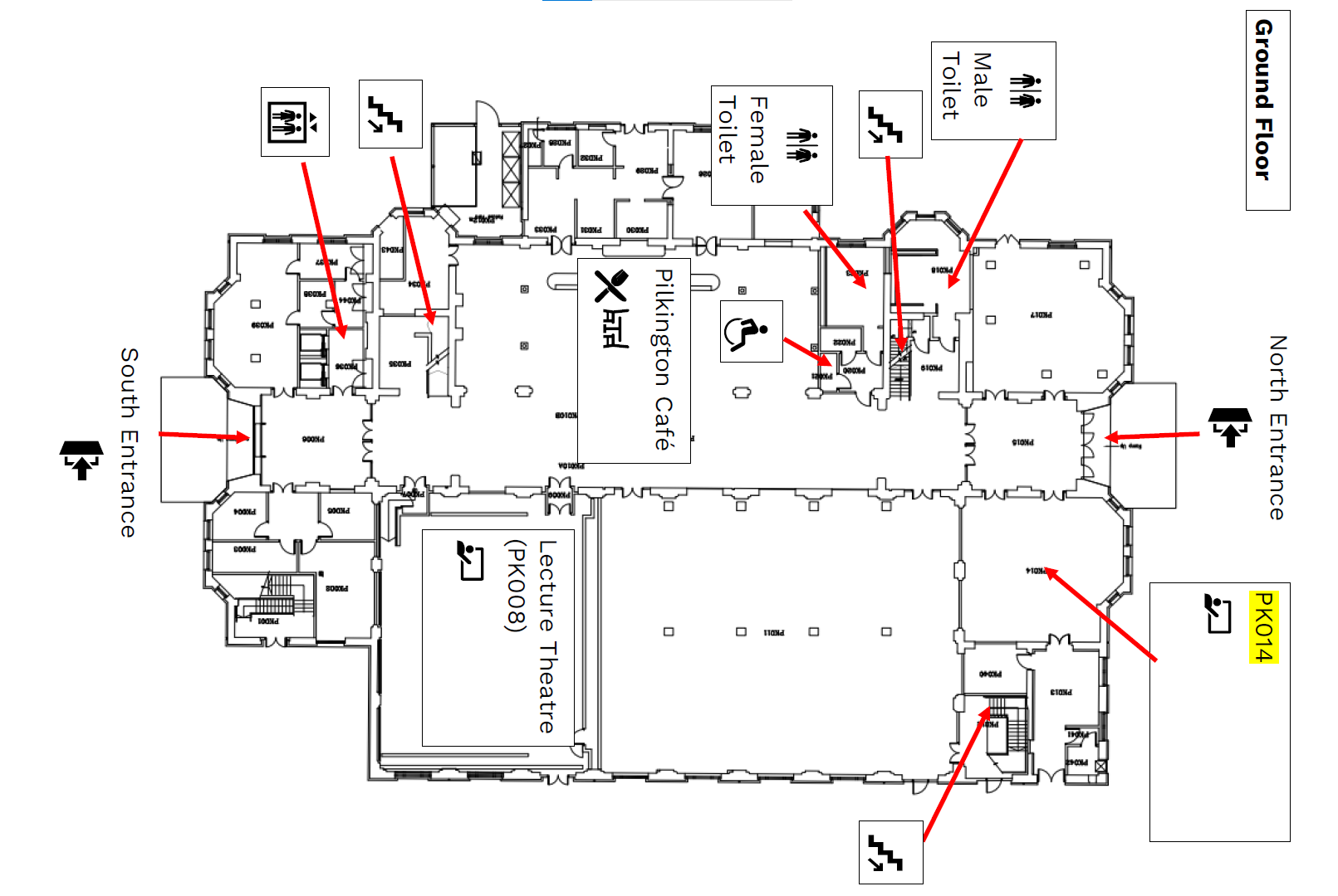
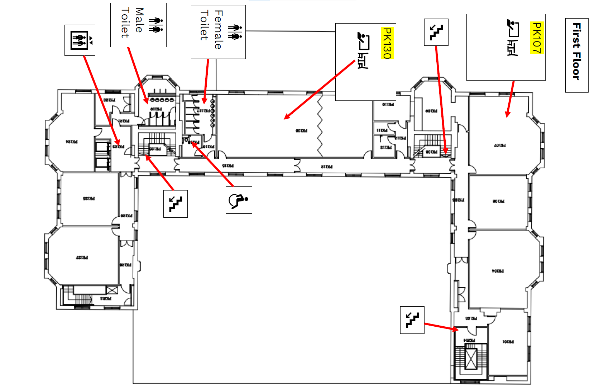

Accessing the Conference in-person
The conference is being held in the Pilkington Building on the Medway Campus in Chatham. The full address for the location is:
Pilkington Building,
Medway Campus,
Central Ave,
Gillingham,
Chatham Maritime
ME4 4TB

Google Maps link here

There are two main entrances to the building:

- North Entrance – faces onto North Road
- South Entrance – closest to the car park on the opposite side of the building to the North entrance

You can view a map of the campus here.

Accessing via Car
The campus estate is shared with University of Greenwich, University of Kent and Canterbury Christ Church University. Each institution has its own parking areas and different permit requirements. Please visit the sites below to plan your journey:
- Greenwich Staff and Students
- Kent Staff and Students
- Canterbury Christ Church Staff and Students

Accessing via Train
Train services are provided by Southeastern, please refer to National Rail Enquiries for timetables. There are two stations for the campus Chatham and Gillingham. We recommend you alight at Chatham station and get one of the bus services listed below but if you prefer, the walk from Gillingham station is shorter and takes around 20 minutes.

Accessing via Bus
Most bus services in Medway are operated by Arriva. There is a service from Chatham bus station to the campus every 15 minutes most of the day stopping on the campus (Service 1), or just outside in Dock Road (Service 2). The journey normally takes between 5 and 10 minutes depending on traffic. These routes and others stopping close to campus are listed below. Timetables are available from Medway Council. Other bus routes requiring a change at Chatham bus station are shown in the Medway bus routes map.
No. | Operator | Route | Nearest stop
1 | Arriva | Chatham Railway Station - Gillingham Strand | On campus
2 | Arriva | Chatham Railway Station - Dockside Outlets | Chatham Maritime St George's Centre
100 | Arriva | Chatham Railway Station - St Mary's Island | Chatham Maritime St George's Centre
101 | Arriva | Maidstone - Gillingham | Chatham Dockyard Main Gate
116 | Arriva | Chatham Railway Station - Gillingham - Hempstead | On campus
170 | ASD | Chatham Bus Station - Strood via tunnel | Chatham Maritime St George's Centre
182 | Arriva | Chatham Bus Station - Gillingham | Chatham Dockyard Main Gate

Staff and students at the university of Greenwich can also get the intercampus bus. For more details and to book tickets visit the webpage here.

Accessibility and amenities
For more details on accessibility, visit the building’s accessibility guide via AccessAble here.
If you have any queries, please contact us via lte-admin@canterbury.ac.uk

Parking
There are Blue badge parking bays located on the west side of the building that are clearly signposted and do not need to be booked in advance.

Getting Around
There are two entrances into the building, North entrance (directly faces North Road), and South entrance (opposite side of the building), which both have step-free access.
Please note, only the south entrance has automatic door entry.
There is step-free access throughout the building via a lift that is in the main foyer.
The lecture theatre (PK008) has accessible door access.
The session rooms have standard doors, but conference organisers will be available to help with access if required.

Toilets
There are both standard Female and Male toilets, and Accessible Toilets located on the Ground and First Floor of the building.
Accessible toilets are located to the left of the stairs, next to the Female toilets.

Food and Drinks
Free refreshments and biscuits will be provided for those attending in person, which will be located on the ground floor outside of the Lecture Theatre (PK008)
There is a café also located in the main foyer of the Pilkington building that will also be selling a variety of drinks, food, and snacks to purchase.
Attendees will also be able to collect a food voucher from the conference registration desk. This will be in PK011. The food voucher can only be used in the Pilkington café to make a single purchase of a main meal and drink/sweet snack. The voucher will cover up to £6. Any additional costs that exceed this limit will have to be paid by attendee.

Getting help
Conference organisers will be present throughout the day in the Pilkington building, who will have a blue spot on their name badge. If you have any questions or require any additional help, please do approach them.

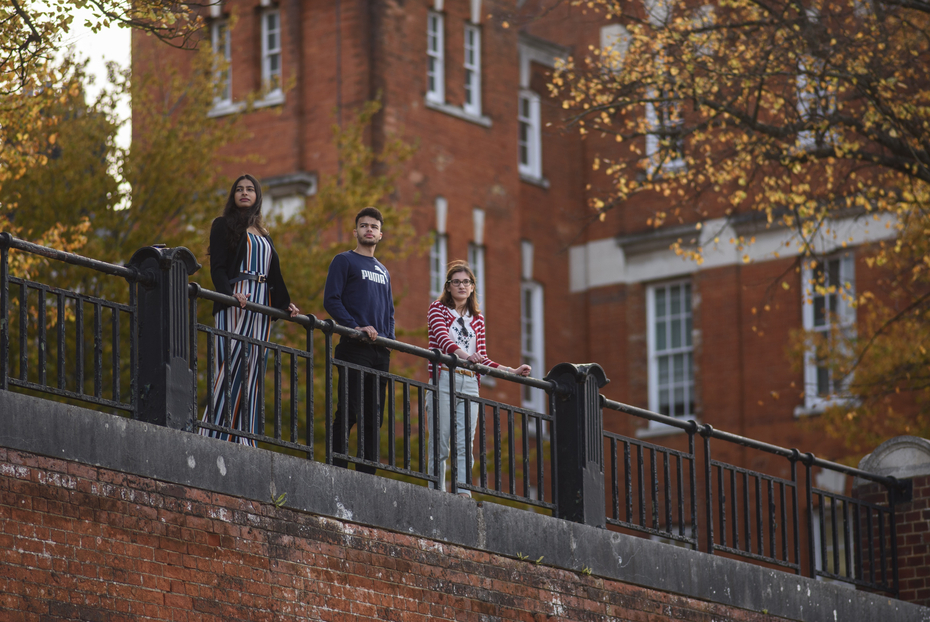

Our Conference Committee

Angeliki Voskou
Annikki Laitinen
Chloe Courtenay
Dan Clark
Jack Charter
James Coleman
Julie Taylor
Kathleen M Quinlan
Lynne Burroughs
Peter Brown
Thomas Gale

Special Thanks

John Luckhurst
Jane Butler
Learning and Teaching Enhancement Team
Pilkington Cafe and Catering Staff

