University Certificate in Academic Practice

Faculty of Arts, Humanities and Education
Learning and Teaching Enhancement

Canterbury
i-zone@canterbury.ac.uk
01227 922222
Ask the iZone

DO YOU have any queries after reading this guide?

for COURSE queries please contact ucap_pgcap@canterbury.ac.uk

for any other queries contact the i-zone:

This handbook sets out a range of information about your course and points to a number of other important documents to help support you through your studies at the University.
The purpose of this handbook is to provide information about your course. It should be read in conjunction with Your Essential Guide, which sets out general information relevant to all students at the University, and your Module Handbooks available on each module Blackboard. You can also find more information about all aspects of the University on the Current Student webpages.
This information is designed to support you throughout your studies. It is important to familiarise yourself with it.

Your
COURSE
Handbook

SALOMONS
i-zone@canterbury.ac.uk
0333 011 7101
Ask the iZone

MEDWAY
i-zonemedway@canterbury.ac.uk
01227 927700
Ask the iZone

CONTENTS
Graduate Attributes Statement 4
Welcome from the Course Director 6
• The Professional Standards Framework (PSF) Explained 6
Course Overview 9
Course duration and modes of study 9
• What are the aims of the course? 9
Course learning outcomes 9
Key Staff and Contact Details 10
How we will communicate with you 11
Key Dates, TIMETABLES and COURSE STRUCTURE 11
Accessing your timetable 11
• Course and Module Timetable 11
UNI WEEK 11
Special Events 14
Welcome Week 14
Academic Development Week 14
Personal Development Week 14
Reassessment Week 14
Learning and Teaching 15
Learning Technologies 15
Developing your skills 17
Assessment 18
• How will you be assessed? 18
Referencing system 18
Assessment criteria 19
How to submit your assessments 19
Self-checking your assessments before you submit 19
Your Guide to Assessment and Awards processes 19
Feedback 19
Preparing for Reassessment 19
Results 19
Regulatory arrangements 19
Personal Academic Tutoring/ Mentoring 20
Student Voice 21
IT support 21
Employability, Careers and Enterprise 22
External Examiner 22

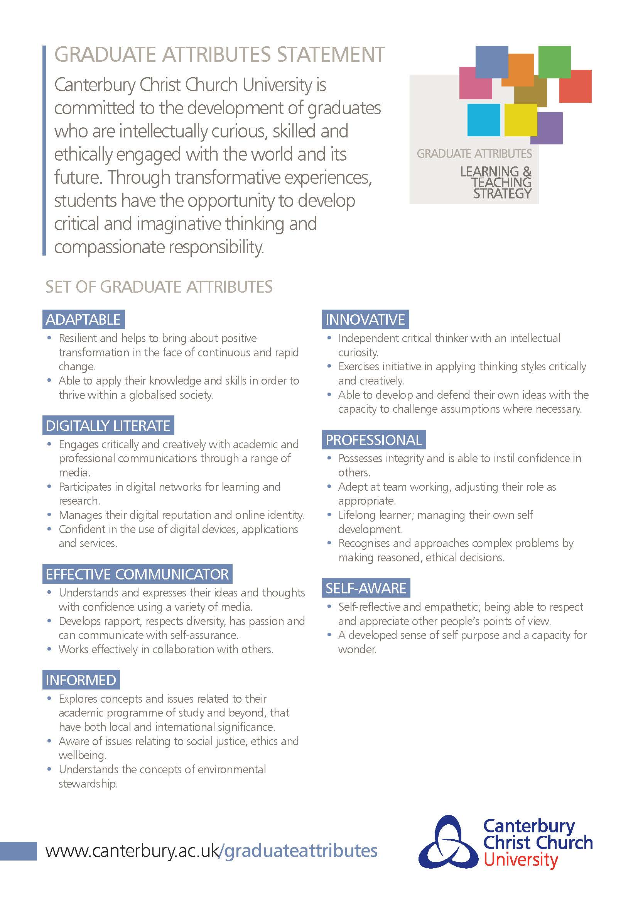

Welcome from the Course Director
Welcome to the University Certificate in Academic Practice. This taught course forms part of the University’s My Accredited Pathway: Higher Education (MAP:HE) framework, which provides ways for all our staff who teach and support learning to achieve recognition in learning, teaching and assessment practices by Advanced HE.

The University Certificate in Academic Practice (UCAP) has been designed specifically for new academic staff and professional service staff who have a role in teaching and supporting learning in Canterbury Christ Church University and our collaborative partners. Successful completion of the course will give you a qualification in higher education academic practice. In addition, provision of appropriate evidence of attainment of specific outcomes will also give you Associate Fellowship of the AdvanceHE (HEA). Please note that if you are a member of staff working in a partner institution, unless your institution is a subscriber of the HEA, you will have to pay the HEA for recognition of the Fellowship.

Higher education has changed greatly over the past twenty years. There has been a significant increase in research and scholarship in higher education which has informed our understanding of how best to facilitate learning, for example away from a traditional model of content ‘transmission’ to one which is student-centred and encourages active learning. The digital revolution has also transformed the ways in which knowledge is managed, accessed and created as well as providing innovative learning environments and opportunities for collaboration. The policy context of English higher education has changed the way universities are funded and managed, with students now entering university with potentially different expectations and demands than previously.

As a new lecturer or professional service staff member you will gain the knowledge, skills and values to be able to manage and develop your students’ learning and progression within this new higher education context.

The course is closely mapped against the United Kingdom Professional Standards Framework (UK PSF) and therefore provides you a transferable and sector recognised award should you continue your academic career elsewhere in the future.

- The Professional Standards Framework (PSF) Explained
The UK PSF was developed through consultation across the UK Higher Education sector and is housed by Advance HE). It is primarily designed to be used flexibly by individuals and institutions as a recognised benchmark for higher education practice in teaching and supporting learning. It should not, however, be mistaken for a competency framework with fixed definitions and performance criteria. The framework is designed to be open to a degree of interpretation to allow contextualisation of roles, institutions and circumstances particular to an individual or institutional context. For this reason, you might initially find the descriptions of the expectations rather vague and feel the need for greater clarification. When you reach the section on preparing for fellowship or if you are undertaking the taught route, you will see that you will be supported in understanding the framework and how best to evidence your claim.
The UK PSF is a simple way of representing a highly complex and dynamic practice. For this reason, people speak of ‘engaging’ with the framework. It has two key components:
- The three dimensions of practice;
- The four descriptors (D1-D4)
The three dimensions; Areas of Activity (A), the Core Knowledge (K) and Professional Values (V) form the core of all academic practice. The four descriptors (D1-D4) describe different types of practice and correspond to the different categories of fellowship: Associate Fellow (D1), Fellow (D2), Senior Fellow (D3) and Principal Fellow (D4). There are common elements to all four descriptors but as you engage with them you will see that they build upon each other. For example, the Fellow (D2) and Senior Fellow (D3) both require a solid practice in learning and teaching but D3 has additional descriptors associated with leadership of learning and teaching.

UCAP - Descriptor 1:  Associate Fellow | Typical individual role/career stage
Demonstrates an understanding of specific aspects of effective teaching, learning support methods and student learning.  Individuals should be able to provide evidence of:  I. Successful engagement with at least two of the five Areas of Activity  II. Successful engagement in appropriate teaching and practices related to these Areas of Activity  III. Appropriate Core Knowledge and understanding of at least K1 and K2  IV. A commitment to appropriate Professional Values in facilitating others’ learning  V. Relevant professional practices, subject and pedagogic research and/or scholarship within the above activities  VI. Successful engagement, where appropriate, in professional development activity related to teaching, learning and assessment responsibilities | Individuals able to provide evidence of effectiveness in relation to their professional role(s), which, typically, will include at least some teaching and/or learning support responsibilities.  This teaching and learning role may sometimes be undertaken with the assistance of more experienced teachers or mentors. Typically, those likely to be at Descriptor 1 (D1) include:  a. Early career researchers with some teaching responsibilities (e.g. PhD students, GTAs, contract researchers/post doctoral students etc.)  b. Staff new to teaching (including those with part-time academic responsibilities)  c. Staff who support academic provision (e.g. learning technologists, learning developers and learning resource/library staff)  d. Staff who undertake demonstrator/technician roles that incorporate some teaching-related responsibilities  e. Experienced staff in relevant professional areas who may be new to teaching and/or supporting learning, or who have a limited teaching portfolio

LTE webpage: Learning and Teaching Enhancement (canterbury.ac.uk)

Course Overview

Course duration and modes of study
The UCAP is a six-month course with entry points in October and April. For this academic year it will be delivered through a blended learning mode with sessions run via Blackboard Collaborate and face-to-face sessions planned when COVID restrictions make this possible.

- What are the aims of the course?
The University Certificate in Academic Practice aims to:
- Provide you with the core knowledge and professional values necessary to design and deliver high quality learning activities within your discipline area of higher education.
- Establish critical reflective practice and enquiry into teaching and learning as the core foundation of being an educator in a higher education context.
- Enhance and develop your practice in learning and teaching against the UK PSF in teaching, facilitating and/or supporting learning.
- Help you to become familiar with sources of research and scholarship on which you can draw to enhance your practice.
- To Award the AFHEA on successful completion of the IFL module

Course learning outcomes
On successful completion of the University Certificate in Academic Practice you will be able to:
- Utilise theory and research in higher education to design and deliver appropriate teaching, learning and assessment activities within your own subject discipline.
- Develop and maintain a critical reflective practice and give and receive constructive peer feedback for enhancement of learning, teaching and assessment.
- Demonstrate critical awareness of the particular needs of a higher education curriculum with reference to the quality requirements and assurance processes of Canterbury Christ Church University, the Quality Assurance Agency and professional and statutory regulatory bodies.
- Demonstrate critical awareness of personal and institutional processes and structures which enhance student experience and engagement within an inclusive learning environment.

Key Staff and Contact Details

Chloe Courtenay (SFHEA)
Course Director
Module Leader: Enhancing Teaching Assessing & Supporting Learning in Higher Education
Module Leader: Small-Scale Pedagogic Inquiry
chloe.courtenay@canterbury.ac.uk
Staff profile: Chloe Courtenay (canterbury.ac.uk)

Claire Loffman (SFHEA)
Module Leader: Introduction to Facilitating Learning in HE
claire.loffman@canterbury.ac.uk
Staff profile: Dr Claire Loffman (canterbury.ac.uk)

Jack Charter
Course Administrator: PGCAP/UCAP
ucap_pgcap@canterbury.ac.uk

Faculty Digital Academic Developer: Lynne.Burroughs@canterbury.ac.uk
Faculty Learning & Research Librarian: Catherine.Sherwood@canterbury.ac.uk
Careers and Enterprise careers@canterbury.ac.uk
IT Services it-services@canterbury.ac.uk

How we will communicate with you
We will contact you with important information and updates via your Student University e-mail address, so please make sure you check your student account e-mails regularly or have them auto-forwarded to your CCCU staff email address. We will stop contacting you on a personal/staff email address once you are registered as a student on the course.

Key Dates, TIMETABLES and COURSE STRUCTURE
Attendance at timetabled sessions (onsite or online) and engagement with your studies is a fundamental part of your learning experience. You must make yourself available to undertake all activities relating to your course. The University will monitor your attendance of onsite and online sessions, and your engagement with Blackboard and Library Services (a Student Engagement Dashboard and Blackboard analytics are used to monitor your engagement). For onsite sessions, make sure you ‘tap in’ to on-campus sessions with your Smart Card.

If you cannot attend a session for any reason, you should let your tutors and Personal Academic Tutor know.

You should also attend at least one Learning and Teaching Conference as these are an excellent way to find out about the latest developments in learning and teaching.

Accessing your timetable
There are a number of ways to keep track of where and when your workshops and other course-related activities are due to take place. See the module and course handbook and the UCAP webpage The University Certificate in Academic Practice (canterbury.ac.uk)

Course and Module Timetable
UNI WEEK | W/B DATE | TRIMESTER TEACHING WEEK
10 | 3-Oct-22 | 2 | IFL Day 1 - Monday 3rd October 2022 9-1 ON CAMPUS Room: MDf04 (Maxwell Davis building)
11 | 10-Oct-22 | 3 | IFL Day 2 - Tuesday 11th October 2022 9-1 ON CAMPUS Room: MDf02 (IT) (Maxwell Davis building)
13 | 24-Oct-22 | 5 | IFL Day 3 - Wednesday 26th October 2022 1-4 pm ONLINE - Blackboard Collaborate
15 | 7-Nov-22 | 7 | IFL Day 4 - Monday 7th November 2022 1-4 pm ON CAMPUS – Jg08 (Johnson building)
16 | 14-Nov-22 | 8 | IFL ‘Day 5’ - Mon 14th, Tue 15th, & Wed 16th November 2022, ON CAMPUS for microteaches (exact microteach slots TBC)
18 | 28-Nov-22 | 10 | IFL Day 6 - Tuesday 29th November 2022 9-1 ON CAMPUS Room: MDf02 (IT) (Maxwell Davis building)
20 | 12-Dec-22 | 12 | IFL Day 7 - Wednesday 14th December 2022 9-1 ON CAMPUS Room: Lg39 (Laud building)

Cohort 2: March intake
32 | 6-Mar-23 | 6 | IFL Day 1 - Monday 6th March 2023 9-1 ON CAMPUS (Room TBC)
33 | 13-Mar-23 | 7 | IFL Day 2 - Tuesday 14th March 2023 9-1 ON CAMPUS (Room TBC)
35 | 27-Mar-23 | 9 | IFL Day 3 - Wednesday 29th March 2023 1-4pm ONLINE - Blackboard Collaborate
36 | 3-Apr-23 | HOL | IFL Day 4 – Mon 3rd, Tue 4^{th ,} Wed 5th April 2023, ON CAMPUS for microteaches (exact microteach slots TBC)
38 | 17-Apr-23 | 10 | IFL Day 5 - Monday 17th April 2023 - 9-1 ONLINE - Blackboard Collaborate
42 | 15-May-23 | 14 | IFL Day 6 – Tuesday 16 May – 9-1, ON CAMPUS (Room TBC)
45 | 5-Jun-23 | 1 | IFL Day 7 – Wednesday 7th June 2023 – 9-1, ON CAMPUS (Room TBC)
 |  |  | Summer Learning and Teaching Conference – End of June, exact date TBC

University 2022/23 calendars can be found at https://www.canterbury.ac.uk/our-students/ug-current/academic-services/timetable-and-dates/university-dates-2022-23 >

Attendance at timetabled sessions (onsite or online) and engagement with your studies is a fundamental part of your learning experience. You must make yourself available to undertake all activities relating to your course. The University will monitor your attendance of onsite and online sessions, and your engagement with Blackboard and Library Services (a Student Engagement Dashboard is used to monitor your engagement). For onsite sessions, make sure you ‘tap in’ to on-campus sessions with your Smart Card.

If you cannot attend a session for any reason, you should let your tutors and Personal Academic Tutor know.

Accessing your timetable
There are a number of ways to keep track of where and when your lectures, seminars, practicals and other course-related activities are due to take place.

Individual Student Timetables (ISTs)
The majority of students have access to an online personalised timetable (usually referred to as an Individual Student Timetable or IST), which tells you where and when your classes are due to take place. Some can be online. If you have an IST, you can access it at mytimetable.canterbury.ac.uk.

Using My Timetable you will be able to import your IST into the calendar service you use most, such as Outlook, Google Calendar, or Apple Calendar.

Course and Module Timetable
You can also view the full timetable for the course(s) you are studying – and any other courses running at Canterbury or Medway campus – via the online timetables at unitimetables.canterbury.ac.uk.

For more information about ISTs and OnTime (the University’s central timetabling database), including full guides and video tutorials, visit the Student Timetables page of the website.

Canterbury Christ Church University is committed to publishing a fully roomed academic timetable before the start of the academic year, and minimising the number of changes thereafter, in order to help you plan ahead and better manage your work-life balance. Amendments to the published timetable may happen due to occurrences outside of the University’s control (such as periods of lockdown), so you are advised to check your IST and/or course timetables regularly.

If you are experiencing problems with accessing your timetable, please contact the i-zone.

- Outlook Calendar Invites
Where the students on this programme are staff, or if you have an Outlook email address, we will also send out Outlook Calendar invitations as we have found this to be helpful in supporting you to balance your normal workload and UCAP studies.

You can also view the full timetable for the course(s) you are studying – and any other courses running at Canterbury or Medway campus – via the online timetables at unitimetables.canterbury.ac.uk.

For more information about ISTs and OnTime (the University’s central timetabling database), including full guides and video tutorials, visit the Student Timetables page of the website.

Your timetable at Canterbury Christ Church University is typically made up of the following for each module that you study:

  - Seminars and workshops that all students studying the UCAP attend
  - Optional additional assignment writing workshops, dates negotiated during the programme, that form part of the mentoring offer
  - Online directed study
  - Supplementary online learning in the form of full online learning objects but also self-directed packaged topics to extend your learning
  - Workplace learning which includes:
  - Your teaching/ supporting learning hour during which you facilitate learning for students
  - Design and planning
  - Reflection on practice
  - Other activities such as peer observation and professional discussion/feedback time
Attendance at timetabled sessions is a fundamental part of the student learning experience. You must make yourself available to undertake all activities relating to your programme of study. If you are unable to attend the session please let your module leader know, copying in ucap_pgcap@canterbury.ac.uk

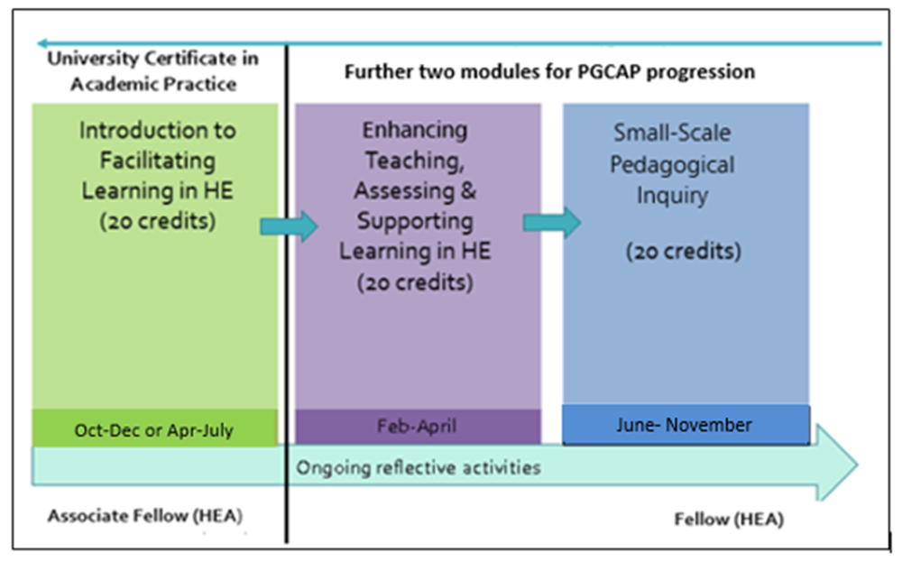

Special Events
As well as your taught sessions, there are special weeks within your timetable for focussed activities. The special weeks that apply to you will depend on your course and level of study.

Welcome Week
This week is targeted at all students starting or progressing onto a new course. It will familiarise you with the University and offer time to get to know students and tutors on your course. It will also showcase the different ways we will support you here at Christ Church and the opportunities to join the wider community through activities like the Students’ Union Freshers’ Fayre.

Academic Development Week
This is a week dedicated to you advancing your learning through focussed activities and allowing you time to prepare for assignments and develop your academic skills. This is a vital opportunity for you and your Personal Academic Tutor to reflect on your academic progress so far and for you to get advice on the next steps you need to take to achieve your full potential. It is also a chance for you to access wider development opportunities around the University for example, in volunteering and peer mentoring.

Personal Development Week
This is a dedicated week for you to engage in focussed activities that will develop your wider skills, enhance your employability and prepare you for your future career.

Reassessment Week
This is when formal reassessment for modules will take place where applicable, as per the calendar above (for more information about reassessment, see Your Guide to Undergraduate/Postgraduate Assessment and Award Processes).

Further information on events, activities and support offered during each of these weeks will be published on the Student Blog throughout the year.

Learning and Teaching
Learning and teaching activities
Classes on the UCAP are a mix of campus and online teaching to give students the chance to learn in different environments. Online sessions are easier for staff members to attend given their other duties but face to face sessions give people the chance to meet each other and form links so that you will feel that you know each other before working together in an online environment. This has been set in this way in response to feedback from the previous UCAP and PGCAP cohorts who felt a mix of online and face-to-face would be ideal.

Learning Technologies
Your tutors will be using a range of learning technologies to support your learning. To become more familiar with the use of these technologies, please refer to the IT Services website.
- The course will use use ReCap or Blackboard Collaborate to record all synchronous sessions so that they can be reviewed. Captioning will be used to make recorded sessions more accessible.
- Asynchronous activities will be delivered via the module and course Blackboard pages.
- Mentimeter, Padlet and Blackboard Collaborate’s whiteboard function will be used to make sessions more interactive and to provide a record of class discussions where appropriate.

Self-study and independent learning
As well as participating in live sessions, you are expected to undertake self-study and learn independently.
The UCAP requires around 200 hours of study (including taught sessions and tutorials) for successful completion. The course has also been designed around a flipped learning model which means that it is essential that you do the prelimiary reading and study for each session so that you can take part in session activities effectively.

The courses are inspired by, and reflect the nine principles that form part of the CCCU Learning and Teaching Strategy 2015-22:

Learning and Teaching Strategy principle | How the UCAP deliver these principles
An integrated approach to Graduate Employability | The UCAP is designed to ensure you complete with the knowledge, skills and values required of an academic practitioner in the current HE sector and context. The course is accredited to the Advance HE (AHE) Dimensions and Descriptor 1 and this further ensures that the course reflects the attributes required for this profession. Additionally, the AHE fellowships are recognised both nationally and internationally thus ensuring the transferable nature of these awards and increasing the employability status of successful participants.
Building learning communities | Building a learning community is integral to the courses. You will be facilitated and given time to know one another, and benefit from the cross disciplinary experiences brought to the sessions. Our alumni contribute back to the course as mentors and as contributors to our conferences, this builds a wide community of practice beyond the duration of the courses.
Curriculum design for transformation | The curriculum is designed to expose you, as students, to as many relevant and, appropriate to the AHE D1 Descriptor, teaching strategies as possible as well as demonstrating inclusive practice. This includes a variety of accessible and inclusive assessment design. It is important that you are given every opportunity to reflect on transformative design first hand to enable you to better consider your own students.  The course utilises a variety of resources and signposts these to participants. These are books, ebooks, journals, twitter feeds and podcasts. This also models for you how you might also meet the needs of your own diverse communities of students.
Educating the whole person | Starting with building a learning community, your personal and professional development is a high priority. It is intended that you will experience a wide variety of resources, teaching strategies and learning opportunities to enhance pedagogical knowledge and critical reflection. Ensuring that you are armed with the tools and knowledge required to fulfil your on-going academic roles and progress in your careers is of utmost importance.
Flexible and responsive learning environments | These are taught courses as we recognise the benefits of networking and rich discussion. However, the demands of our participants are highly considered and not only a wealth of multi-media supportive resources made available through Blackboard but relevant CPD and conferences are also encouraged and advertised as we recognise that these types of independent learning might suit some of you more.
Internationalisation and global citizenship | The AHE Fellowships are recognised internationally.  The course also draws upon up to date scholarly resources, case studies and examples from across the globe.
Outstanding learning, teaching and assessment practices | The learning, teaching and assessment practices are designed to provide ‘role modelling’ for new academic practitioners. Using a wide variety of teaching strategies, in particular, collaborative and co-operative strategies such as ‘think-pair-share’ and ‘jigsaw’ are used to provide examples of how to design for and delivery within an inclusive environment. This is particularly important to support the University Retention and Success Framework.
Students as partners in learning | You will be invited to evaluate sessions, give feedback on an ongoing basis and contribute to the direction of learning throughout each module. As well as more structured types of feedback, through the module surveys for example. You will be invited to join the course team in curriculum design workshops as co-creators of the design of the module and aspects of delivery.
Supporting success for all students | We recognise that you have many conflicting demands upon your time. To maximise your success, we plan our assessment calendars to avoid peak marking times as far as possible. We provide mentoring and tutorials in a number of ways; through online support, group sessions and we also offer individual mentoring. Observations and developmental feedback of authentic practice are carried out at times and venues to best support you, the participants.

In addition, you will receive mentoring as part of a learning set and personalised feedback from teaching observations. Your mentors are all people who hold an HEA fellowship at D2 (Fellow) or above. Most are alumni of the course. They have been trained in individual, group and online mentoring and assessment of practice. In addition, their training includes supporting you in meeting the requirements for recognition of the UK PSF descriptors, D1 (and D2 should you progress to the PGCAP).

The University Certificate in Academic Practice (UCAP) is formed of one module, worth 20 credits at Level 7. Once you are enrolled, you will undertake the Introduction to Facilitating Learning in HE module which begins with an intensive two-day workshop on critical reflective practice and learning and teaching. Introduction to Facilitating Learning in HE (IFL) is mapped against the D1 descriptor of the UK Professional Standards Framework (UKPSF) which go towards your achievement of Advance HE (see pp. 7-8). If you complete this module successfully you will exit the course being awarded the Associate Fellowship.

Developing your skills
Your Learning Skills team offer guidance on enhancing your skills in finding, using and evaluating information, academic skills to prepare, write and reflect on assignments, and your digital capabilities. We offer:
- workshops that groups of students or your tutors can request, tailored to your requirements;
- one-to-one tutorials and other activities for students timed specifically around your assessment needs;
- a service which is responsive to your academic progress and which prioritises attainment, success and employability;
- high quality online resources for you to use whether you are on campus or not.

Learning Developers and Learning & Research Librarians are based in each Faculty to provide advice that will help you become a successful, independent learner during your time at CCCU and beyond.

Find out more, access resources and book one-to-one tutorials by going to Blackboard (https://learn.canterbury.ac.uk) and clicking the Student Support tab. For more information about what help we can provide email learner@canterbury.ac.uk

Self-study and independent learning
As well as participating in live sessions, you are expected to undertake self-study and learn independently
The UCAP requires 200 hours of study and you should attend a minimum of 4 out of the 7 taught session.

Developing your skills
Your Learning Skills team offer guidance on enhancing your skills in finding, using and evaluating information, academic skills to prepare, write and reflect on assignments, and your digital capabilities. We offer:
- workshops tailored to your requirements that are organised by tutors, or can be requested by groups of students;
- one-to-one tutorials and other activities for students to offer personalised guidance according to identified academic needs;
- a service that is responsive to your academic progress and which prioritises attainment, success and employability;
- a range of online modules, accessed via the Learning Skills Hub (https://www.canterbury.ac.uk/learning-skills-hub), that aim to support you in developing the academic skills you need to succeed at and beyond University
Learning Developers and Learning & Research Librarians are based in each Faculty to provide advice that will help you become a successful, independent learner during your time at CCCU and beyond.

To find out more about the team, access specialist modules and resources or book a one-to-one tutorial visit the Learning Skills Hub. For more information on our offer, you can also email learner@canterbury.ac.uk.

Assessment

The assessment strategy of the course aims to be integrative, whereby all strands of assessment are brought together coherently to support learning and achievement. There will be opportunities for formative assessment prior to summative assessment and the assessment tools will be chosen to align with the module outcomes, UKPSF descriptors and learning tasks.

- How will you be assessed?
The module will be assessed and you will receive a grade in line with the standards set out for work at Level 7 and in line with the Regulation and Credit Framework for the Conferment of Awards.

The assessment will draw on your ongoing work while developing your critical reflective practice and will therefore have many opportunities for formative feedback from course staff, peers and mentors. You will present elements of your reflections to be assessed summatively via an inclusive range of assessments types such as a review of authentic practice and either written or recorded reflections.

Referencing system
We recommend that you use the Harvard referencing system but you may use a referencing system you are familiar with in your own School provided this is used consistently. See Cite Them Right

Assessment criteria
Please see the module handbook and Blackboard.

How to submit your assessments
UCAP assessments should be submitted through TurnItIn, the University’s e-submission service. TurnItIn allows you to check your assessment to avoid plagiarism. Find out how to submit to Turnitin here.

Learn more about the University’s computing systems and learning technologies here. This covers everything from logging in and getting started to using Blackboard and Turnitin.

Self-checking your assessments before you submit
For coursework submitted via TurnItIn, you will be able to submit a draft of your work to determine whether you are at risk of having plagiarised. The module Blackboard will offer draft Turnitin submission points to allow you to do so.

Your Guide to Assessment and Awards processes
If you want to learn more about University assessment and award processes these guides provide key information about how assessment is carried out, the formal steps involved in making a final award, and the University’s Regulation and Credit Framework that governs academic awards.

Feedback
You will receive your feedback on TurnItIn. The University has a 15 working day turnaround time for providing feedback, with the exception of a few assessments (such as examination and independent studies).

Once you have access to your marked work you should take time to read through/listen to comments, look at the highlighted assessment grid, and reflect on the guidance in the comments in Turnitin or Pebblepad. You can then consider what aspects of the feedback can feed into your own targets and actions to develop your academic work. Find out more about using your feedback here.

Preparing for Reassessment
If you have not passed assessment and have reassessment contact your Personal Academic Tutor or Course Director and ask for a tutorial to support you to re-engage with assessment or what you have to do to resubmit for reassessment or retake an exam. Find out more about how we can support you with your reassessment here.

Results
Your final results will only be confirmed after the meeting of the Board of Examiners. You will get your final results in an academic summary from Registry.

Contact your tutor if you have any questions about how, when or where to submit your assessments.

Regulatory arrangements
This course operates within the Regulation and Credit Framework for the Conferment of Awards, which provides the regulatory arrangements for the University’s courses.

This sets out how your degree classification will be calculated and the requirements for obtaining your award. The regulations are explained in more detail in Your Guides to Assessment and Award Processes.
On successfully graduating from this course, you will be granted Associate Fellowship of Advance HE.

Personal Academic Tutoring/ Mentoring
All students are offered mentoring, which is provided in several formats. We offer mentoring online through discussion boards and email, through group mentoring which often take the form of assignment tutorial workshops and you can also be allocated an individual mentor (who will have previously completed the PGCAP) and will have Advance HE Fellowship at D2. Early in the course you will be sent a survey asking you for your preferences.

The course team will take the role of Personal Academic Tutors when it comes to extension requests etc.
Please note that all requests for extensions should be made to the Course Director via the course administration email: ucap_pgcap@canterbury.ac.uk

You should make yourself aware of the information on the Extenuating Circumstances webpage so that you are fully aware of these options should you need them.

Please note that workload is not a recognised reason for an extension. However, should you have an ‘unexpected’ change in your workload which can be verified you can speak to the Course Director about this. It is usually helpful to speak to your Module Leader first of all though.

You may find it helpful to consult the list below to help you know who to speak to about different situations:

Personal Academic Tutor
- Pastoral issues and some academic skills
- Extension requests
Mentor
- Subject specific queries
- Observations
- Generic university related queries
Course Director
- Interruptions
- Withdrawals
- Course level queries
Module Tutor/Lead
- Module specific queries regarding materials, assessments etc.
Unless the query is sensitive it is best to always copy in ucap_pgcap@canterbury.ac.uk

Student Voice
If you want to be more active and represent your course and peers, there are several ways you can do so. For example, you can become a Student Rep for your course or Faculty and also get involved in the Students' Union.

Your course will run an election for course reps at the beginning of each academic year.

School and Faculty reps are elected via the Students’ Union. To get involved head to the SU website where you can find details on how to stand for school/faculty rep and even Union Council: ccsu.co.uk

The University is keen to hear your views on your course and course delivery, and one of the ways this takes place is through Student-Staff Liaison Meetings. Meetings normally take place once per trimester, and provide a chance for you to feedback course issues to allow staff to improve the quality of the student experience. The elected student representative(s) will attend these meetings, to raise the views of fellow students and report back to their peer group on the outcomes. Matters relating to individual students are not discussed at SSLMs.

As a student rep you are also involved in representing your peers at academic meetings to improve the experience of all students, such as boards of study, annual monitoring, and course approval or review. Your Course Team will let you know when there are opportunities to get involved.

All course reps are supported by the Students' Union who can be contacted on coursereps@ccsu.co.uk or see https://ccsu.co.uk/yourvoice/studentreps.

IT support
The IT department offers a range of support services to help you with your studies. You can access IT services by visiting www.canterbury.ac.uk/it. There you will find:
- Email and calendaring
- IT training and drop-ins
- Free and discounted software (including Microsoft Office)
- How to take free official certified Microsoft exams
- Information on printing, OneDrive, Wi-Fi, and where to find a PC
- Plus much more…

Employability, Careers and Enterprise
All courses at Christ Church are aligned to our Future 360 Framework for Developing Enterprising, Professional Graduates (2019-2024).

To enhance your employability the Careers and Enterprise Hub provides a wide range of services and activities supporting this framework including:
- 1:1 careers guidance appointments
- Online resources i.e. AI and other tools to support your career development and job success
- Advice on writing CVs, personal statements and cover letters
- Regular online and on-campus workshops and events including job fairs
- Courses leading to Microsoft accreditation etc.
- Bursaries to assist with travel and other expenses related to gaining work experience
- Volunteering and part-time job opportunities with Unitemps
- Advice on starting your own business, enterprise workshops and the chance to attract seed money for your business idea
- And exclusively for final year students the opportunity to enrol in our exciting GradForce programme designed to fast track you into local graduate level employment
- Plus much more…
Visit: https://www.canterbury.ac.uk/current-students/careers-and-volunteering/careers-and-jobs/careers-and-enterprise-hub or email: careers@canterbury.ac.uk

External Examiner
The University appoints External Examiners to act as an independent check on the academic standards of each module and the overall award. This is in line with the QAA UK Quality Code and part of the University’s approach to assuring and enhancing academic quality for all of its academic provision.

External Examiners are drawn from higher education providers and industry. External Examiners are appointed by the University through a formal appointments process which assesses each External Examiner’s qualifications and experience within their subject specialism to confirm their suitability for the role. External Examiners are independent of the University. The University operates two-types of External Examiners, those which are subject specialists and appointed to individual modules, and those which are appointed to Progression and Award Boards and make recommendations about progression and award for your course.

At some point during your course, you might be asked to meet the External Examiner(s). This meeting will be to allow the External Examiner to gather information on the quality and standards of the modules/course. Individual performance will not be assessed at this meeting and External Examiners do not consider issues regarding individual assessment outcomes. The External Examiner for your modules/award submits an annual report, which can be made available to students upon request.

