Enhancing Employability – An Overview

1.0 Why Employability?
Enhancing employability is a University priority. There is a growing expectation that the HE student experience includes developing an awareness of how knowledge and skills acquired support the individuals’ ability to be successful in their chosen career and adapt effectively to change.

In light of the Teaching Excellence Framework (TEF), graduate employability is now of even more significance as employment data will be used to influence (rightly or wrongly) judgements about programme performance.

2.0 What is Employability?
“The things employers generally value in new graduates are things that most teachers in higher education generally value” Harvey & Knight (2003)

Employability and good learning are closely aligned and not contradictory constructs. An employable student and a good learner both demonstrate a breadth of skills, knowledge and understanding, self-belief to explore independently, the ability to manage their time and the resilience to learn from feedback.

Enhancing employability is about adding value to the curriculum by making explicit what we do already and helping students recognise the employability skills and attributes they are developing as part of their study.

Employability is not simply about finding a job, setting up a business or freelancing. It is about making connections between study, personal development and other activities that influence the individuals’ ability to find, gain and be successful in their chosen employment: [employability is] “A set of achievements - skills, understandings and personal attributes - that make individuals more likely to gain employment and be successful in their chosen occupations, which benefits themselves, the workforce, the community and the economy.” (Knight and Yorke, 2003).

In their CareerEDGE model, Dacre, Pool & Sewell (2007) suggest that graduate employability incorporates five key elements:
- Career development learning — Decide – Opportunities – Transition – Self-Awareness (DOTS Model, Law and Watts, 1996)
- Experience — reflecting the fact that having some form of work or life experience is likely to help a graduate develop a wider range of skills, positively impact on degree performance and make them more attractive to prospective employers.
- Degree subject knowledge, understanding and skills
- Generic skills
- Emotional intelligence — “the capacity for recognising our own feelings and those of others, for motivating ourselves, and for managing emotions well in ourselves and in our relationships” (Goleman, 1998)
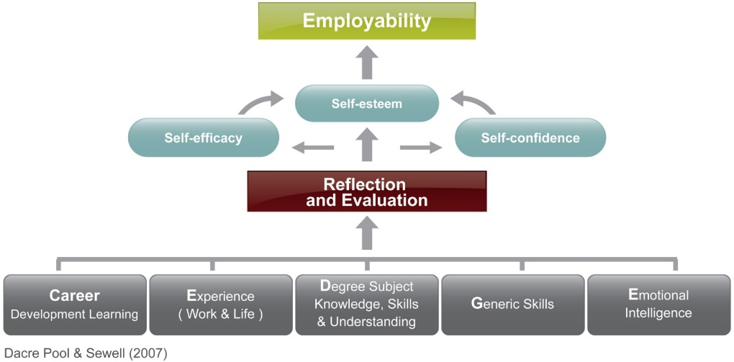

Employability – what it is
- It is a lifelong process
- It applies to all students whatever their situation, course or mode of study
- It is complex and involves a number of areas that interlink
- It is about supporting students to develop a range of knowledge, skills, behaviours, attributes and attitudes which will enable them to be successful not just in employment but in life
- It is a university-wide responsibility
- It is about making the components of employability explicit to students to support their lifelong learning

Employability - what it is not
- It is not about replacing academic rigour and standards
- It is not necessarily about adding modules into the curriculum
- It is not just about preparing students for employment and/or self-employment
- It is not the sole responsibility of the Careers Department
- It is not something that can be quantified by any single measure. (Destinations of Leavers from Higher Education (DLHE) survey is a measure of employment not employability.)

3.0 Curriculum Design for Employability
It is important to take a holistic approach to integrating employability into programme design and delivery. Innovative learning, teaching and assessment methods which promote students’ understanding and help them to engage in ‘deep’ learning will also enhance their employability. We need to consider both what is taught and how it is taught, with pedagogies adopted that provide students with the opportunity to develop and enhance their skills and attributes as well as acquiring knowledge and understanding. It is not is about replacing core subject content, rather it is about how students learn and apply their discipline.

There is no single model for integrating employability. Every curriculum will look different and should be discipline specific. However, curriculum design and delivery for employability is likely to include elements of the following:
- Opportunities for, and active encouragement of, work-related experiences, such as work experience, volunteering experience linked to the curriculum, project work for an employer, live briefs. CCCU is committed to all undergraduate programmes including a compulsory and assessed element of work-related experience, to the value of twenty credits or equivalent, in the form of a single module or across modules and levels. Please see the ‘Work-related experience key principles’ document for further information.
- Employer/Alumni involvement, including advisory boards for programme development, mentors, involvement in assessment, providing case studies and project briefs, guest speakers and placement providers.
- Include real-world examples.
- Active teaching, for example, problem solving, real-world activities, team activities, consultancy projects, competitions.
- Opportunities for students to enhance their skills and attributes – adaptable, digitally literate, effective communicator, informed, innovative, professional and self-aware (CCCU Graduate Attributes).
- Enterprise education, to develop creativity, innovation, confidence and resilience; skills for both entrepreneurs and intrapreneurs.
- Career development learning.
- Featured across the programme, and build year-on-year – through modules which all offer opportunities to build skills, understanding, personal responsibility and decision making.
- Opportunities for reflection, articulation and planning on individuals’ development.
- Supported by a Personal Academic Tutoring system which provides an opportunity for students to have career and personal development discussions.

4.0 What to consider next
- Consider conducting an employability audit of your curriculum - understanding your current employability position is key to knowing what you do well and what could be improved.
- Use Destination of Leavers from Higher Education (DLHE) and NSS data as well as feedback from students, alumni and employers to inform your audit.
- Employability data and audit can help action plan, better promote your employability successes (a marketing tool and in preparation for subject TEF) and help identify priorities for enhancement.

Career Development, Faculty Directors of Learning and Teaching, and Learning, Teaching Enhancement can support you to integrate employability in your curriculum

5.0 Useful Resources
The HEA Mapping Employability Toolkit (recommended)

Cole, D. and Tibby, M (2013). Defining and developing your approach to employability – A framework for higher education institutions. The Higher Education Academy

JISC: Developing student employability project – reports, case studies and toolkit

Employability is a hallmark of degree-level qualifications - http://www.qaa.ac.uk/en/Publications/Documents/qualifications-frameworks.pdf

Jonesa, Green and Higson (2015) Do work placements improve final year academic performance or do high-calibre students choose to do work placements? Studies in Higher Education
“Over a third of recruiters who took part in the research repeated their warnings from previous years – that graduates who have had no previous work experience at all are unlikely to be successful during the selection process and have little or no chance of receiving a job offer for their organisations’ graduate programmes.” High Fliers’ Graduate Jobs Survey 2017.
Cole and Tibby (2013) ‘Defining and Developing your Approach to Employability’, HEA

